Help and Support
Overview
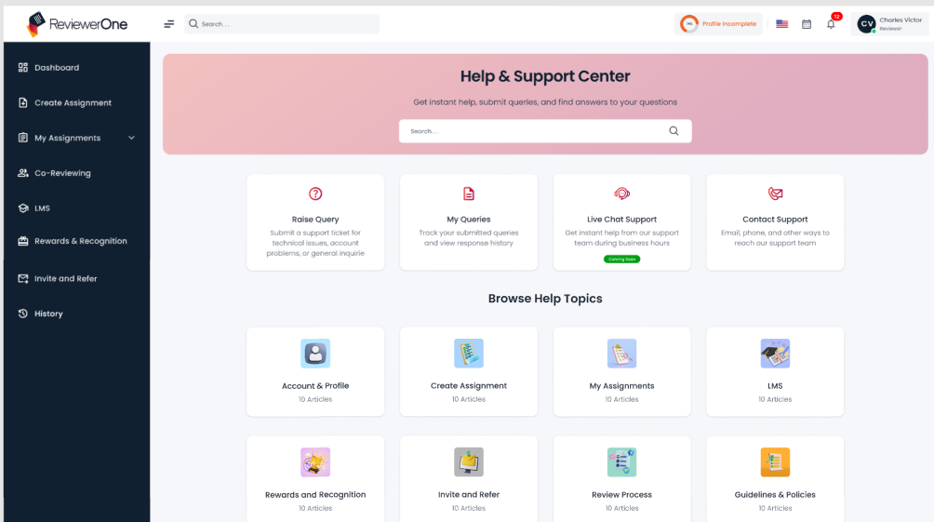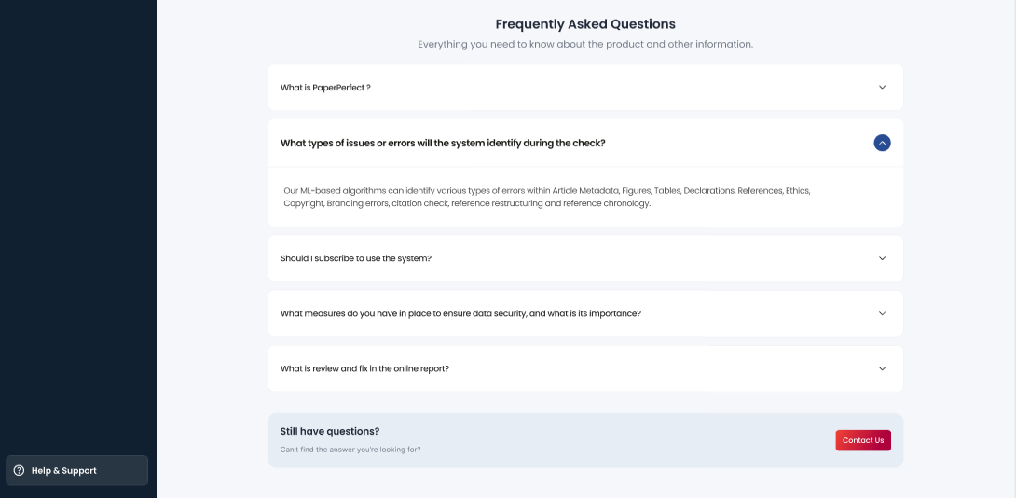
In the ReviewerOne system, the Help and Support Centre is available through the left sidebar menu, providing users with a centralized space to seek assistance and resolve issues. This section includes four main options: Raise Query, which allows users to submit any technical or process-related queries; My Queries, where users can track the status of their previously raised issues; Live Chat Support, offering real-time assistance; and Contact Support, for direct communication with the support team (Coming Soon).
Beneath these options, there is a section titled Browse Help Topics, which provides categorized support content across various areas such as Account and Profile, Create Assignment, My Assignment, LMS, Rewards, and Recognition, Invite and Refer, Review Process, and Guidelines and Policies. Users can navigate these topics to find relevant information and raise queries based on their needs.
Additionally, the Frequently Asked Questions (FAQs) section is available at the bottom. This feature enables users to quickly access answers to common questions, helping them resolve minor issues independently and improving the overall user experience within the platform.
If the user does not find a satisfactory answer in the FAQ section or is unable to locate a solution to their query, they can use the "Contact us" option available in the action tab to directly reach out to the support team for further assistance.

Raise Query
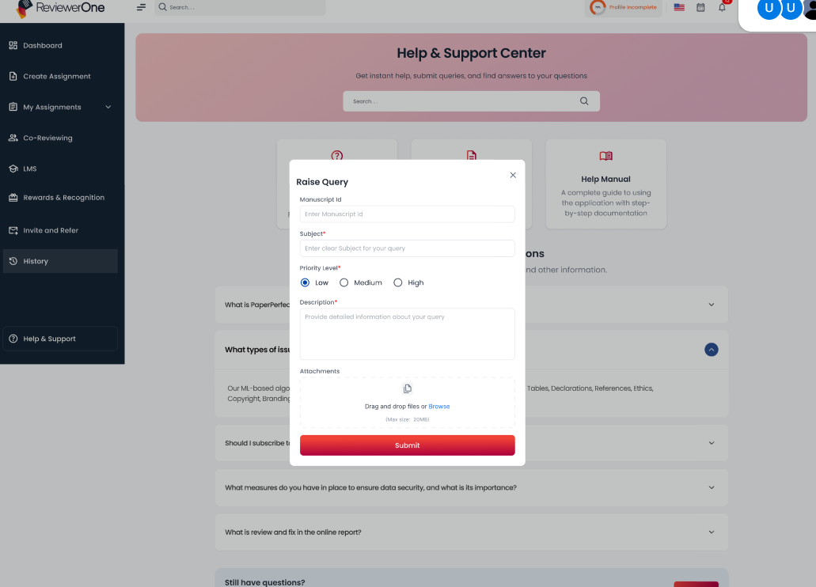
When the user clicks on the "Raise Query" option in the Help and Support Center, a dedicated form opens, allowing them to submit their concern in a structured manner. The form requires the user to fill in key details such as the Manuscript ID, Subject of the query, and Priority Level (e.g., Low, Medium, High) based on the urgency of the issue.
There is also a Description field where the user can provide detailed information about the problem or query they are experiencing. To support their submission, users have the option to upload relevant documents or screenshots using the Attachments section. Once all necessary fields are filled out, the user can click the Submit button to send their query to the support team for resolution. This streamlined process ensures effective communication and faster issue resolution.
My queries
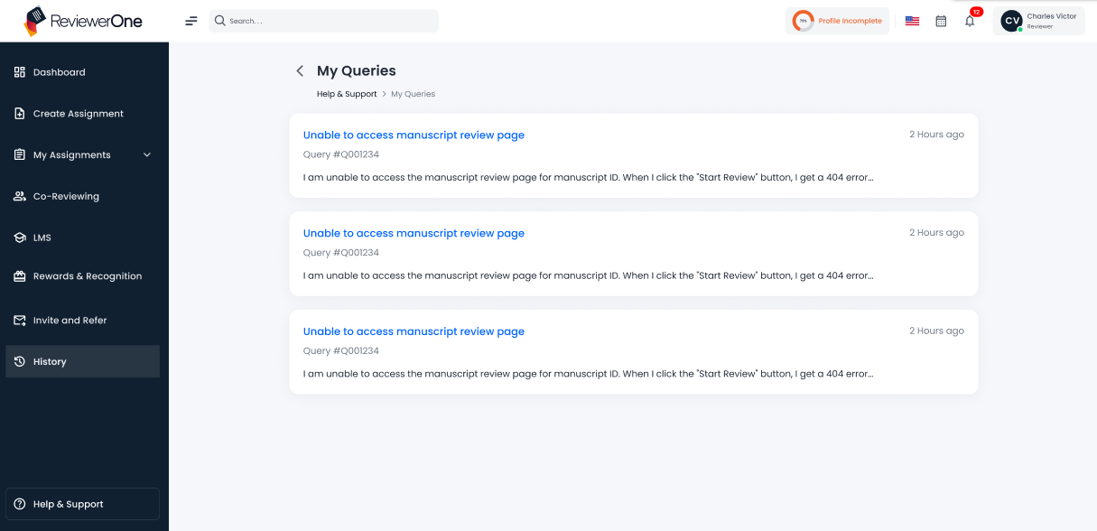
When a user clicks on "My Queries", they are redirected to a dedicated page that displays all the queries they have submitted so far in a card-based layout. Each card provides key information such as the subject line of the query, a unique query ID, the issue category, the time since the query was raised (e.g., "2 hours ago"). This feature helps users stay informed and track the progress of their raised issues efficiently.
Upon clicking on the particular query, the following tab will open on screen.

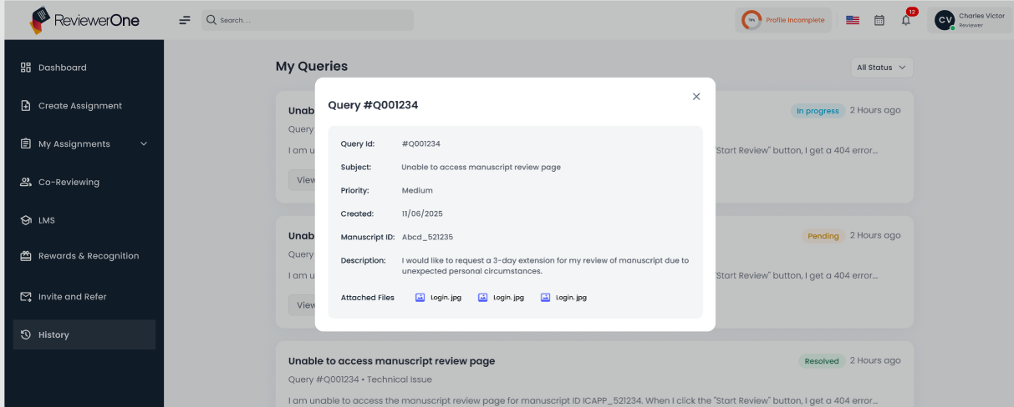
Once the user clicks on particular query in My Queries section of the Help and Support Center, they are directed to a detailed view that displays the associated information, helping the user stay updated and informed. The page includes essential details such as the Query ID, which uniquely identifies the query, the Subject summarizing the issue, Priority level (Low, Medium, or High) set at the time of submission, the Created Date, and the Manuscript ID if the query pertains to a specific manuscript. The Description field captures the user's detailed explanation of the issue and attached file will display on this page that files submitted by reviewer during submitting query.

Coming soon- Live Chat Support Option
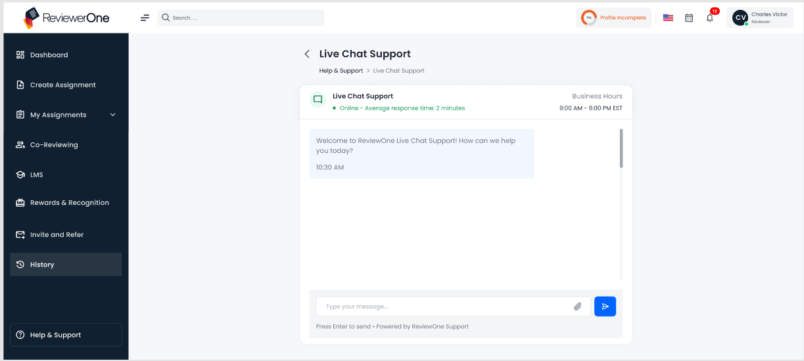
If a user is not satisfied with the response received for a submitted query, they can use the two additional features: Live Chat and Contact Support.
In the Live Chat Support option, users can view the online or offline status of the support team, along with a tagline stating the average response time (2 minutes) and the business hours. The chat interface displays the messages sent by the user and the replies received, along with timestamps for each. Users can type their query or message, attach files, and send them using the send icon.

Contact Support
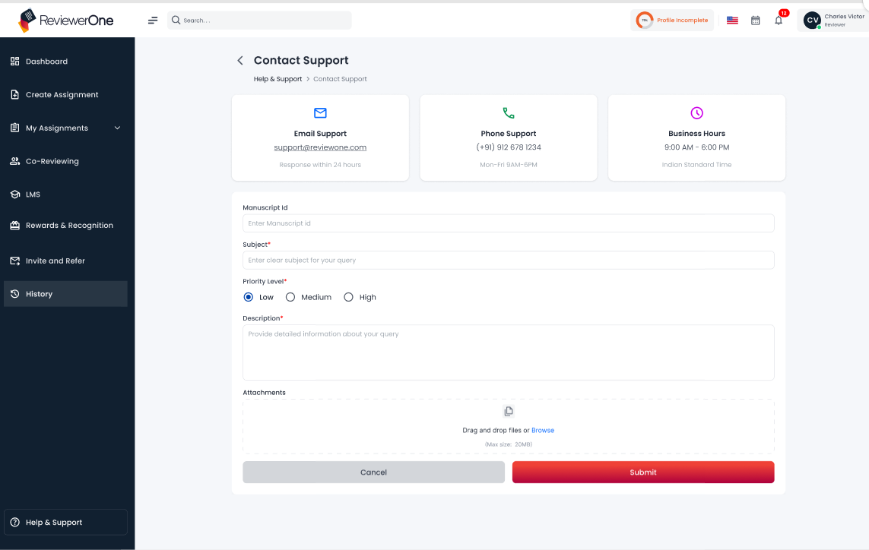
On the Contact Support page, users can access two main support options: email support and phone support. The official ReviewerOne support email address is provided, with an average response time of 24 hours. For direct assistance, an official contact number is available, with phone support operating Monday to Friday from 9:00 AM to 6:00 PM. Users can choose either option based on their preference during business hours. When raising a query, the reviewer must enter the Manuscript ID related to the query, provide a subject, select the priority level (Low, Medium, or High), and add a detailed description. An attachment option is also available to upload relevant files. Once all details are provided, the reviewer can either cancel the request or submit it to the support team for further action.

Browse Help Topics
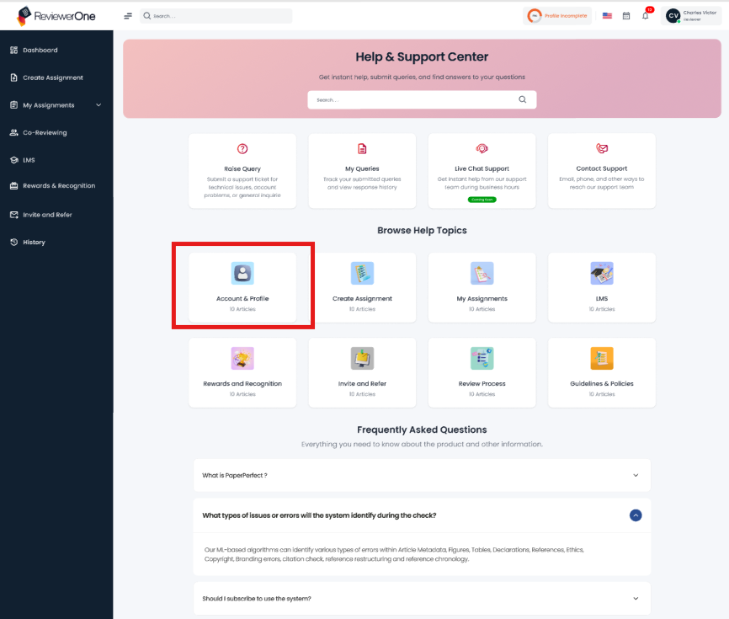
Users are provided with a Browse Help Topics option, where all the modules of ReviewerOne are listed. Each module contains detailed information related to its features and functions. If a user has a query about any specific module, they can simply click on the module name to directly access the relevant information. Along with the module information, FAQs related to that module are also provided, allowing reviewers to find answers to their queries in that section as well. As shown in below image.
