Grammr.ai Website document
Please design the grammr.ai website with a layout similar to the PaperPerfect website. Use only the content provided by Amrita Ma'am for this site. Ensure that all instances of the PaperPerfect logo are replaced with the grammr.ai logo.
Do not reuse any images from the PaperPerfect website.
At this stage, just integrate nGrammr into grammr.ai, including login and related functionality.
Only include the relevant content required for grammr.ai — no additional or unrelated content should be used.
Note: The functionalities are similar to PaperPerfect, just a few points are removed, and the text is changed.
Website along with User Management:
At the top, it contains
- Home (should direct to home page)
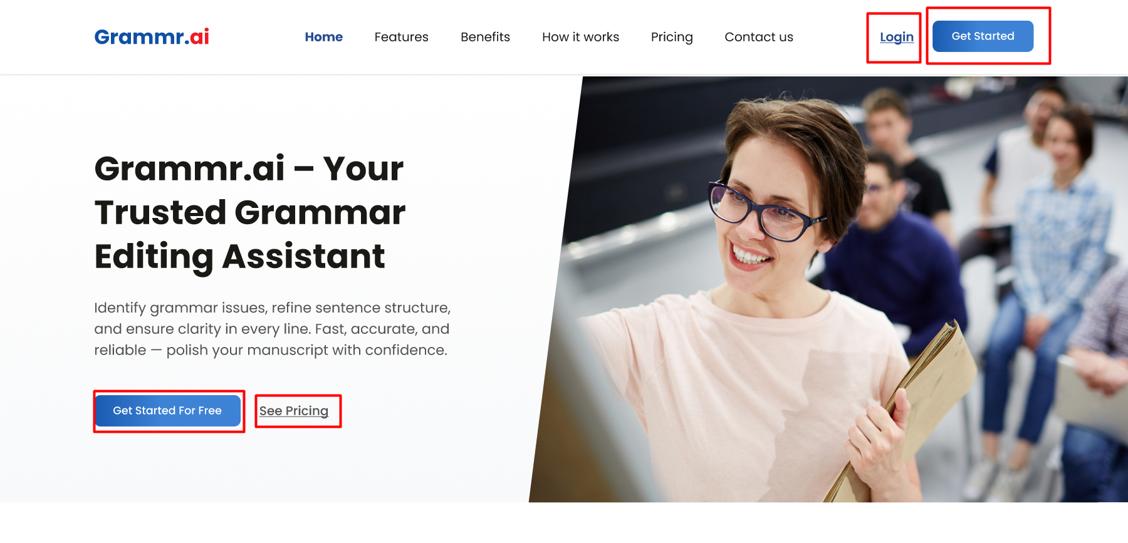

- Try grammr.ai free and Get started now
It should be directed to the Registration page as shown in the screenshot below.
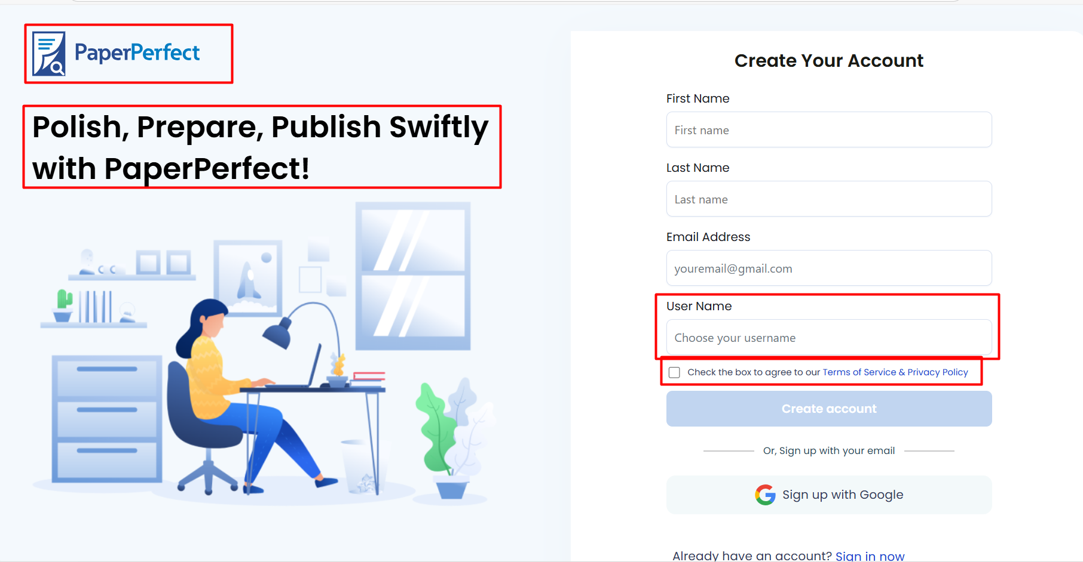

- Features (should direct to Features page)
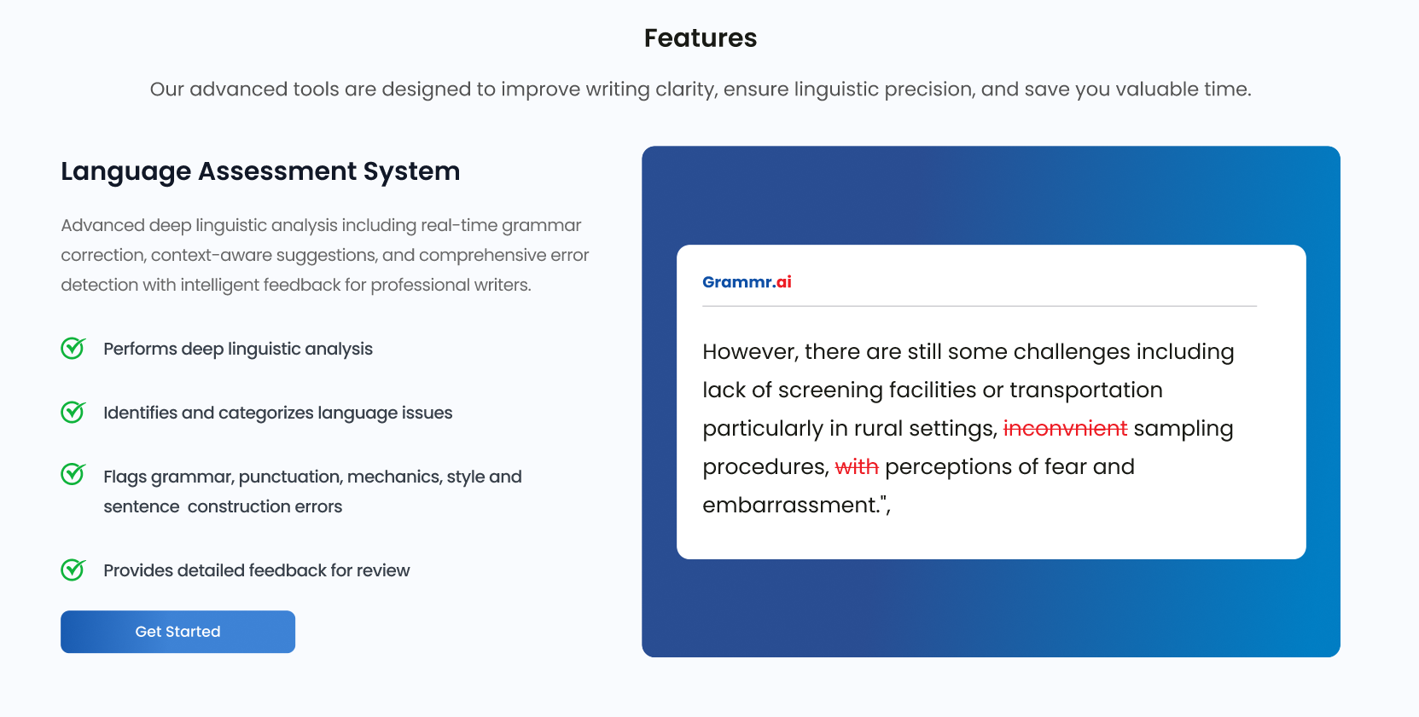
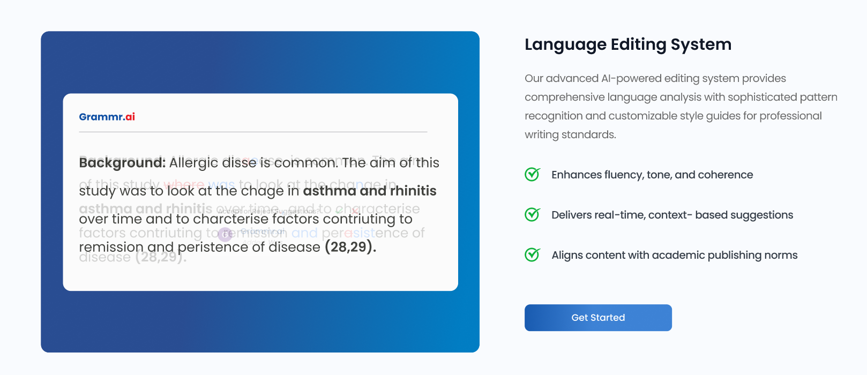
- Get started (should direct to the Registration page as like PaperPerfect)
- Remove the PaperPerfect Logo, and the tag line should be replaced with the below one.
- "Perfect Grammar, Powerful Impact – with Grammr.ai!"
- Remove check box for Terms and conditions and also remove Username.

- Benefits (should direct to Benefits page)
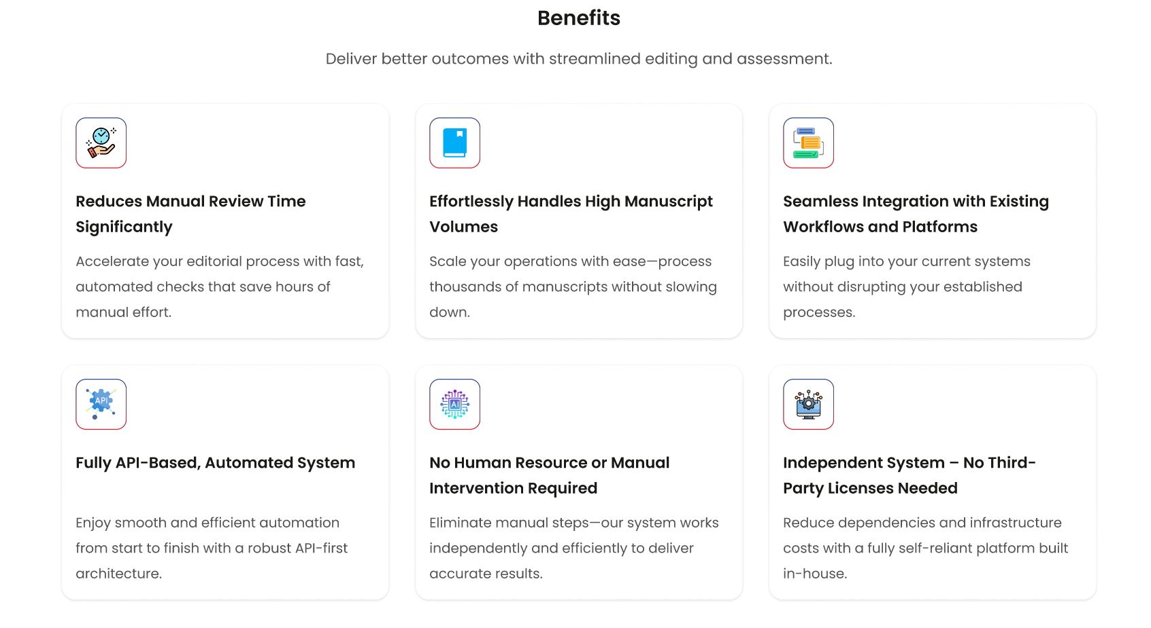
- How it works (should direct to How it works page)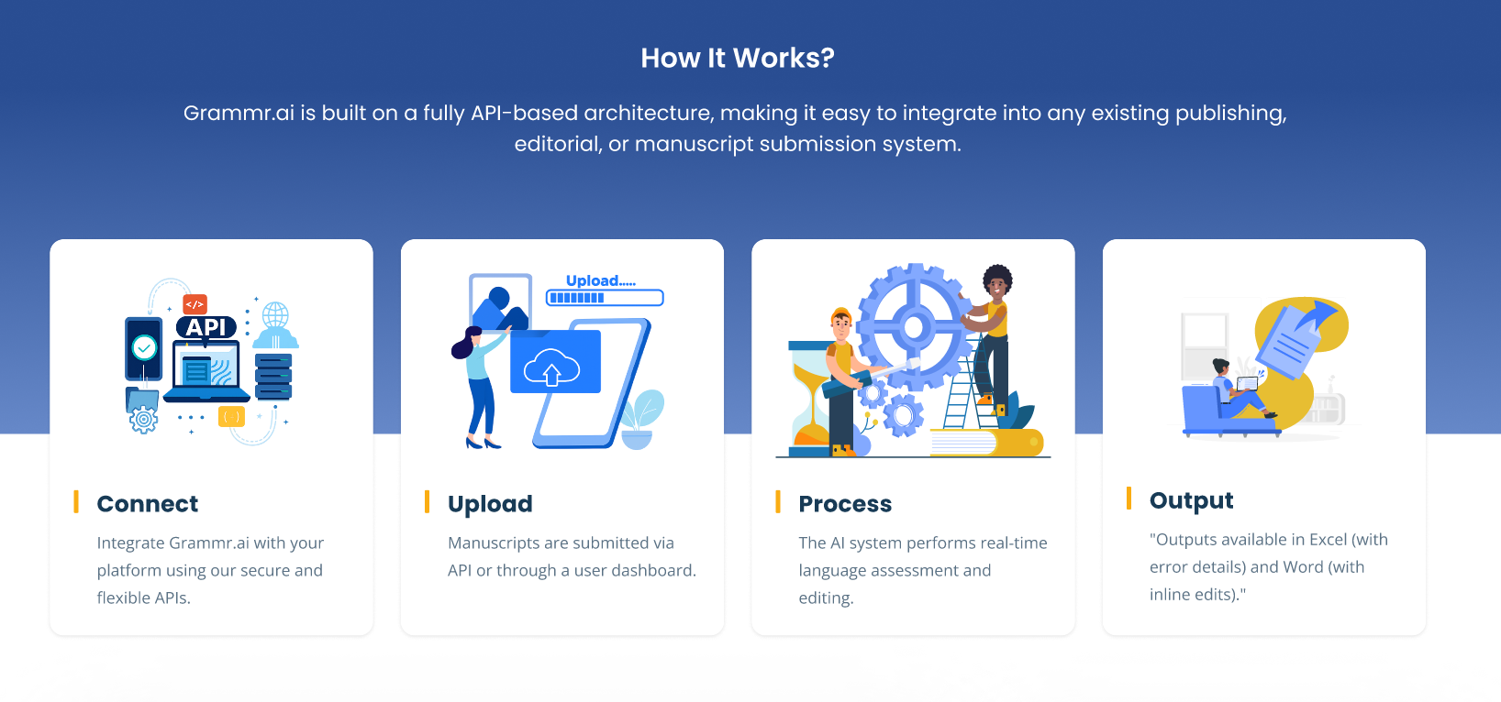
- 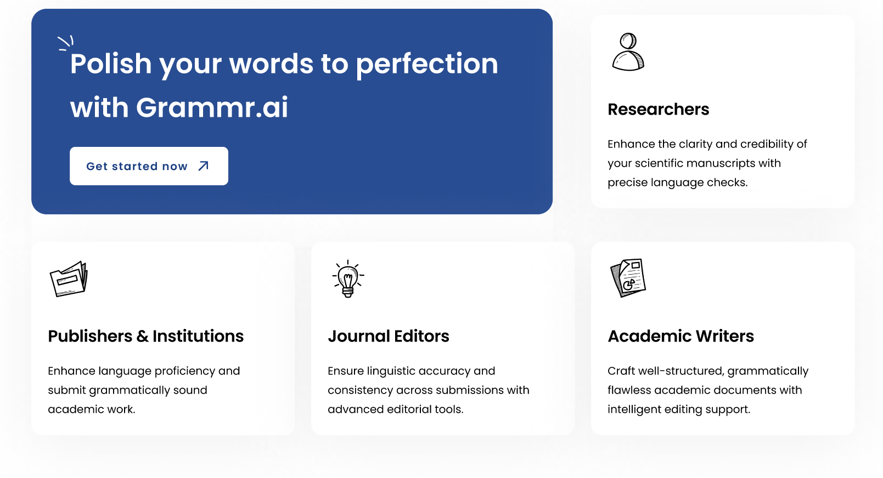Get started now (should direct to the Registration page as like PaperPerfect)

- Pricing (should direct to Pricing page)
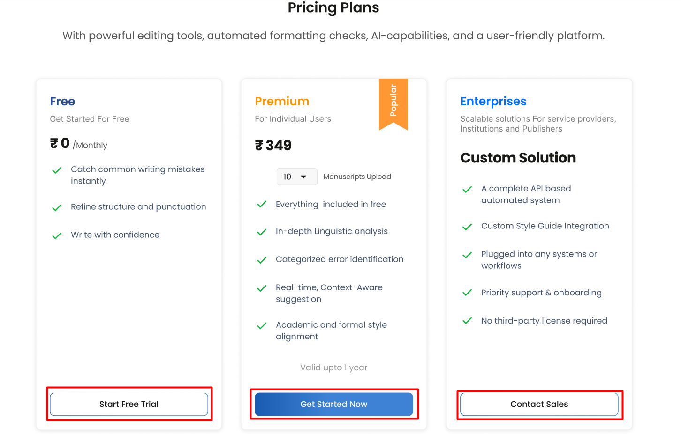
- Start Free Trial, and Get Started Now should direct to the Registration Page.
Contact Sales should be directed to the Contact information page and follow the same process as PaperPerfect.
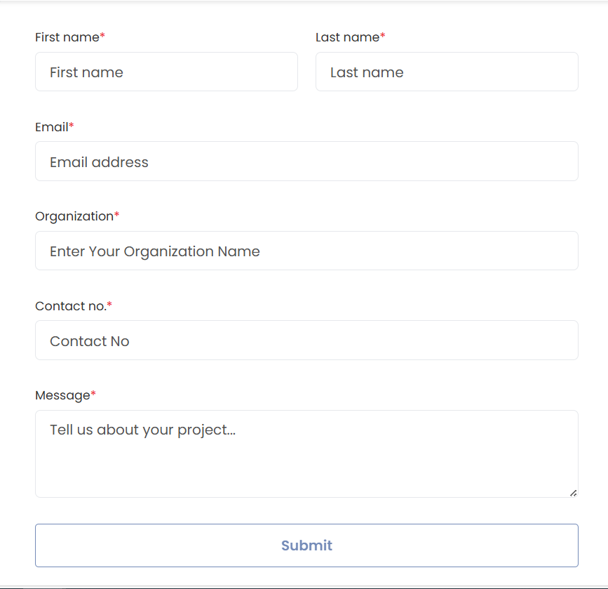
Contact Process: Include a pop-up message directing users to a contact form.
- Once the contact form is submitted by the user then a pop-up and Email should be triggered.
Pop-up: "Thank you for reaching out! Our team will contact you soon."
Email to user:
Subject: Thank You for Contacting Grammr.ai – We’ll Be in Touch Shortly!
Hi [User's Name],
Thank you for reaching out to Grammr.ai . We have received your request via our contact form, and our support team is currently reviewing the details.
One of our representatives will get in touch with you shortly to discuss your requirements and provide a customized quotation tailored to your institution’s needs.
If you have any urgent questions in the meantime, please feel free to reply to this email directly.
Best regards,
Grammr.ai support team
support@grammr.ai | www.grammr.ai

Email to the support team:
Subject: Quotation Request Received – [Institution Name]
Hi Team,
A new contact form has been submitted by a representative from an institution or university requesting a quotation for our services. Please find the submission details below:
Institution/University Name: [Institution Name]
Contact Person: [Full Name]
Email Address: [Email]
Phone Number: [Phone]
Additional Notes: [Any specific requests or messages]
Submission Date & Time: [Date and time stamp] (this should reflect the date and time they applied)
Kindly review the above details and reach out to the contact at the earliest to understand their requirements and provide a tailored proposal.
Please prioritize this request and ensure timely follow-up.
Thanks,
Grammr.ai Support Team

Then,
- Personalized Quotation: Arrange one-on-one discussions to understand the institution's requirements. Provide a custom quotation based on the number of individuals in the Institution and Universities.

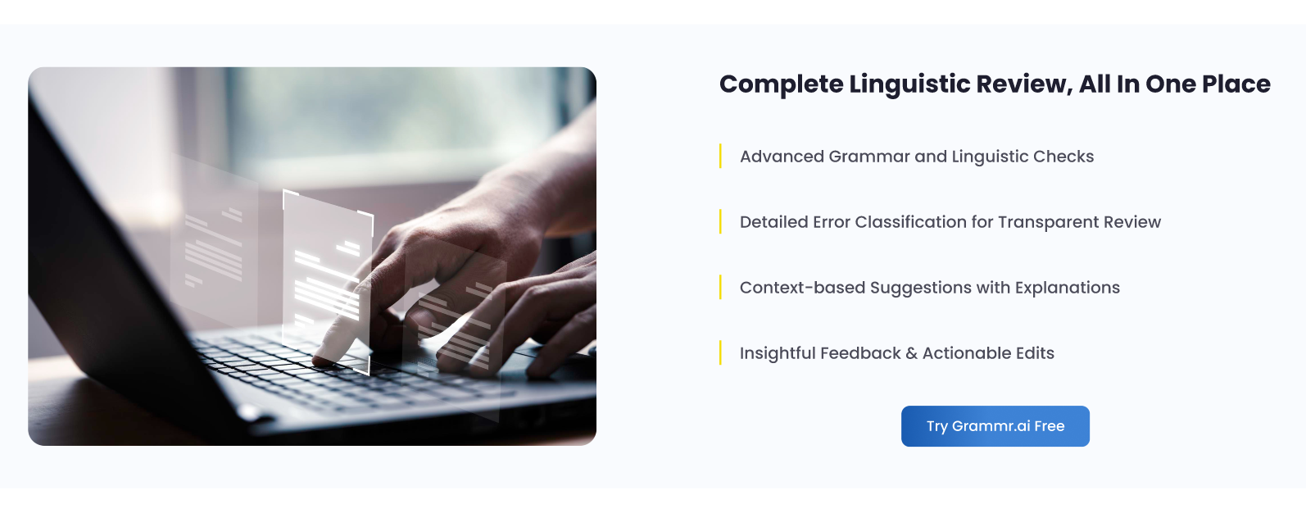

- Try Grammr.ai Free should be directed to the Registration Page.

- Contact Us (should direct to Contact Us page)
- 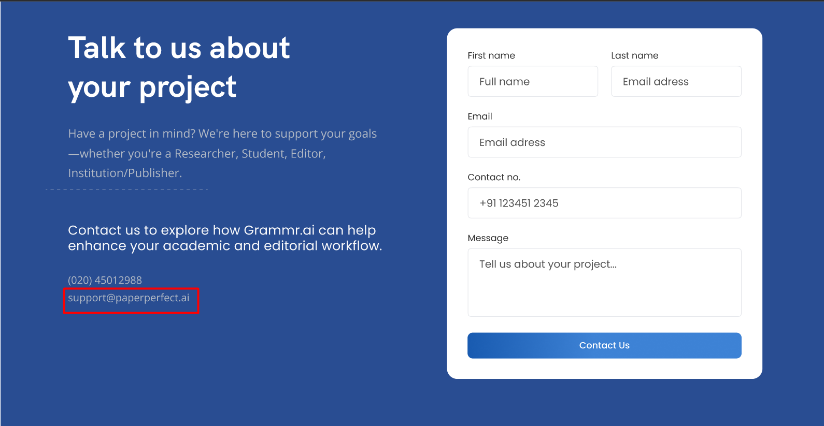
- Remove Support@paperperfect.ai and replace it with support@grammr.ai
- Login (should direct to Sign in page as like PaperPerfect)
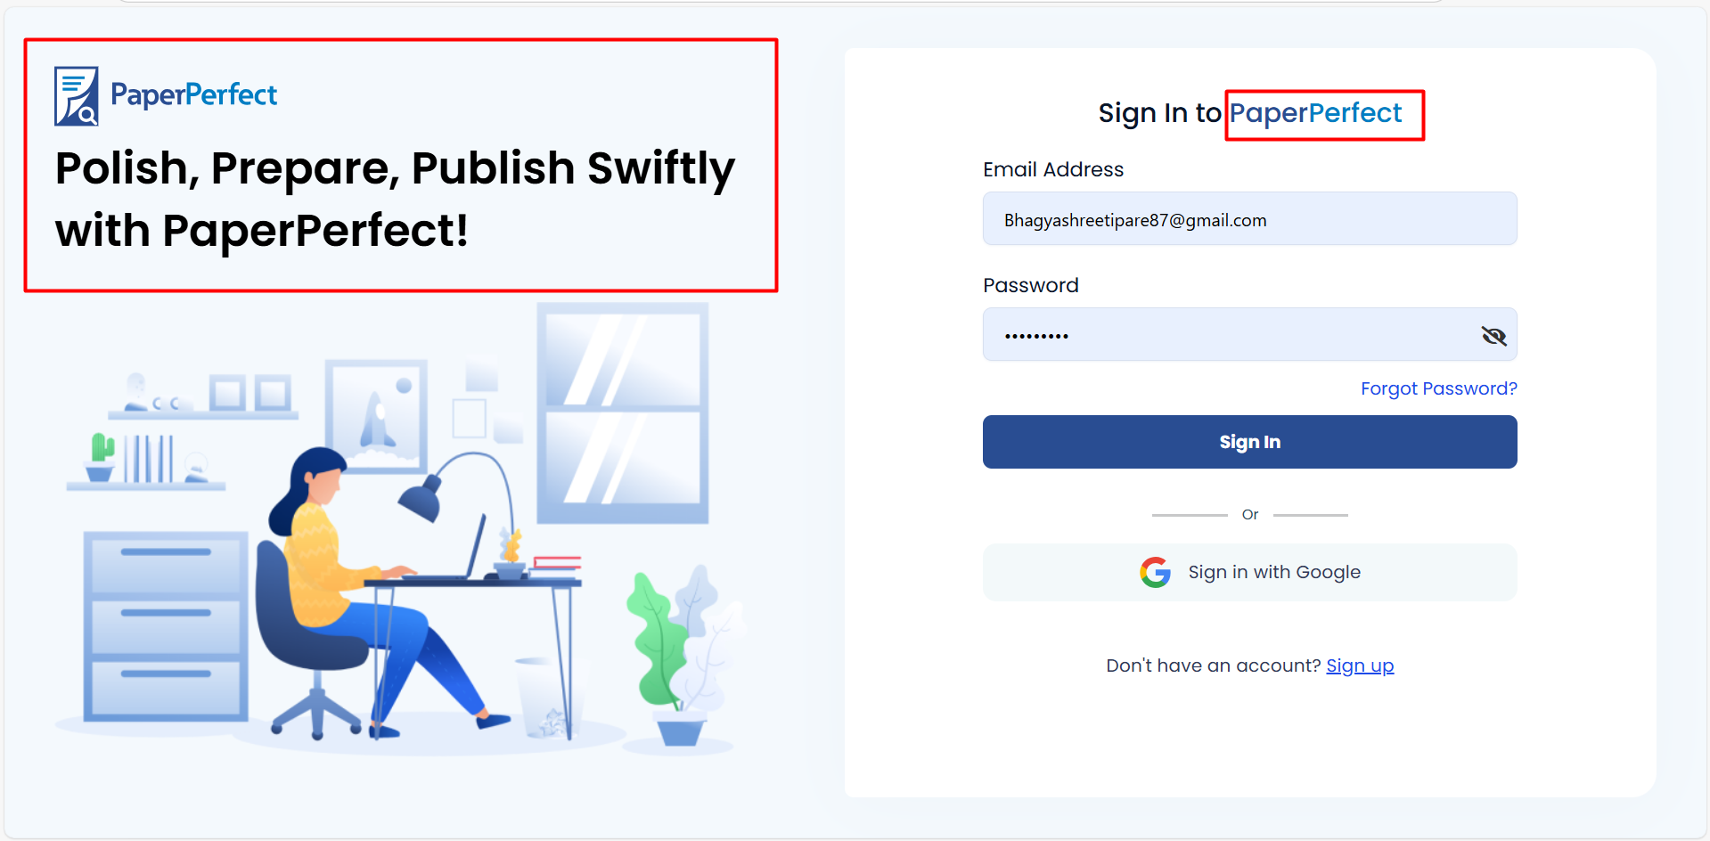
Replace PaperPerfect logo with Grammr.ai logo and Replace tag line with the below tag line
"Perfect Grammar, Powerful Impact – with Grammr.ai!"

- Get started (should direct to the Registration page as like PaperPerfect)
After login the user will be directed to the Dashboard shown in screenshot below.
Remove reference style section from the text, also remove the need help option for now. The content that is scrolling should be removed. Other points should be kept as it is in PaperPerfect.
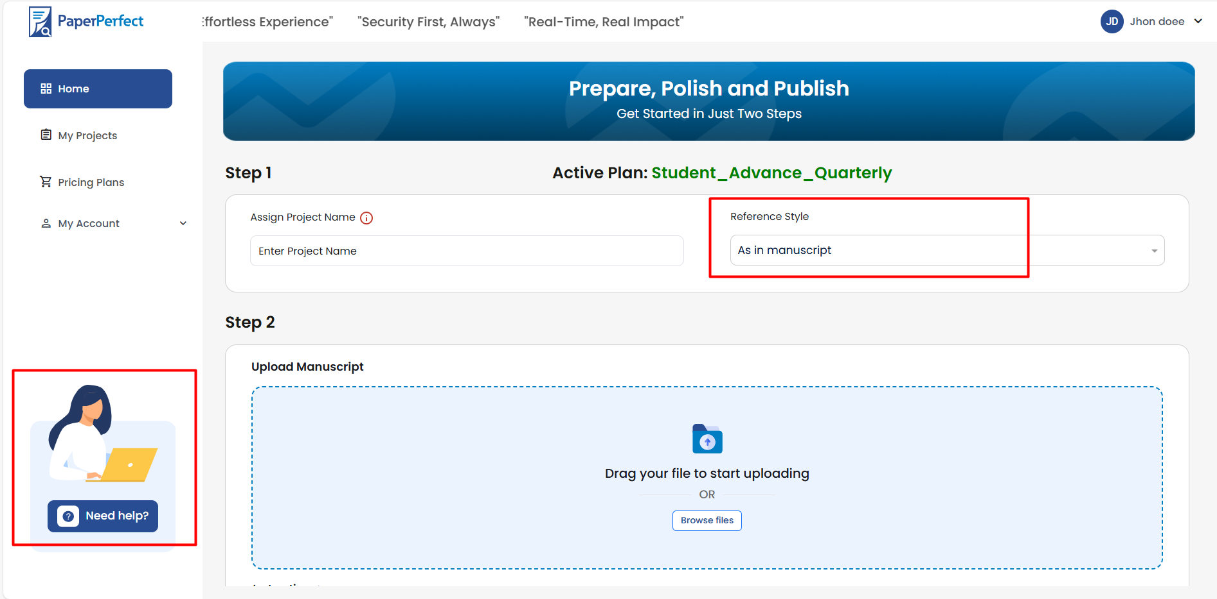
Replace PaperPerfect logo with grammr.ai logo.
Replace the content highlight with the content given below.
"Clear Grammar. Stronger Manuscripts."
Below the upload option in the instructions option, just add Instructions:
Grammr.ai works with English Manuscripts only.
Remove active plan

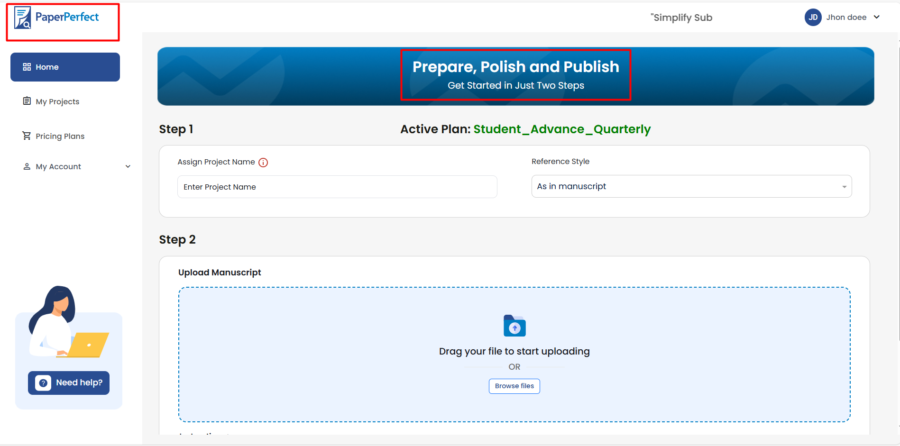
After uploading a file. Directly go to My projects Tab.
In the My Projects tab, all functionalities should be similar to PaperPerfect.
Remove the scrolling text, need help, view option, upload option, and replace the PaperPerfect logo with Grammr.ai logo.
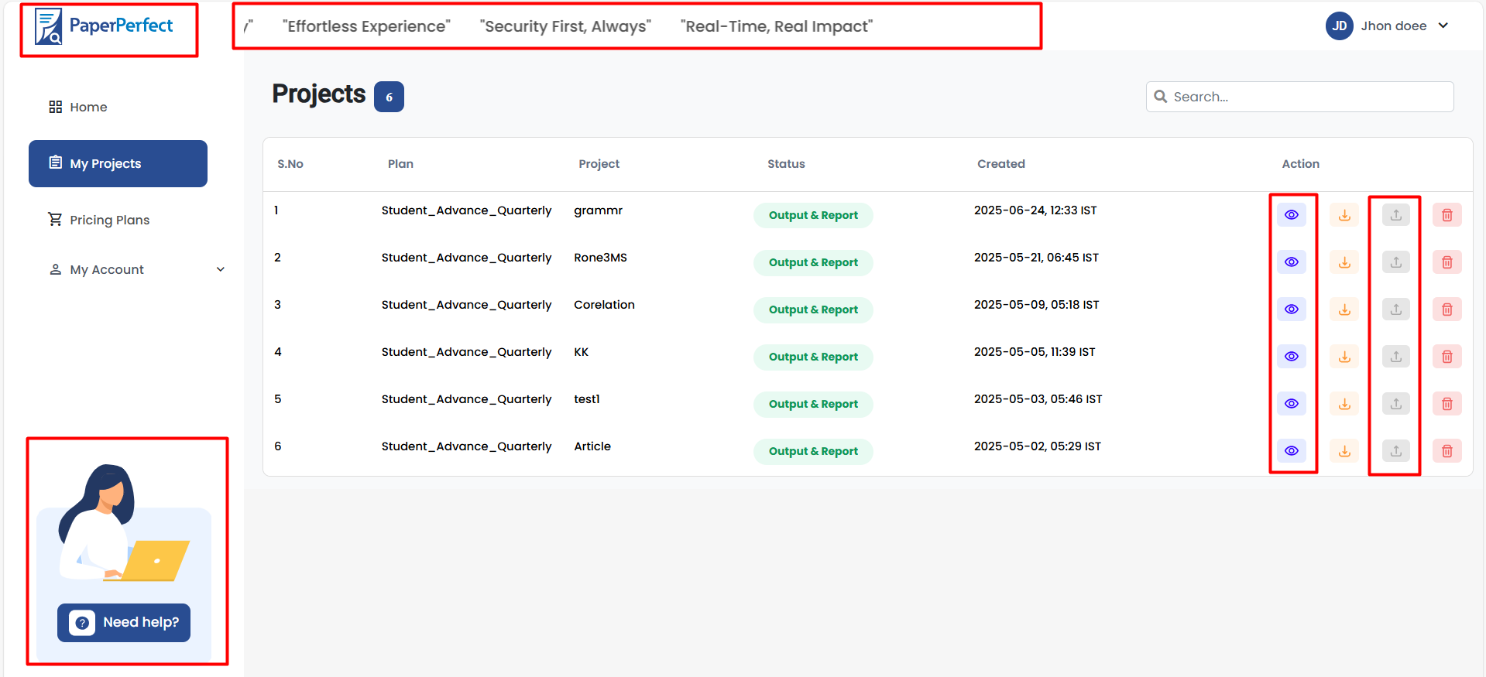
In Pricing Plans, show Pricing plans as per the designs provided by jagdish.
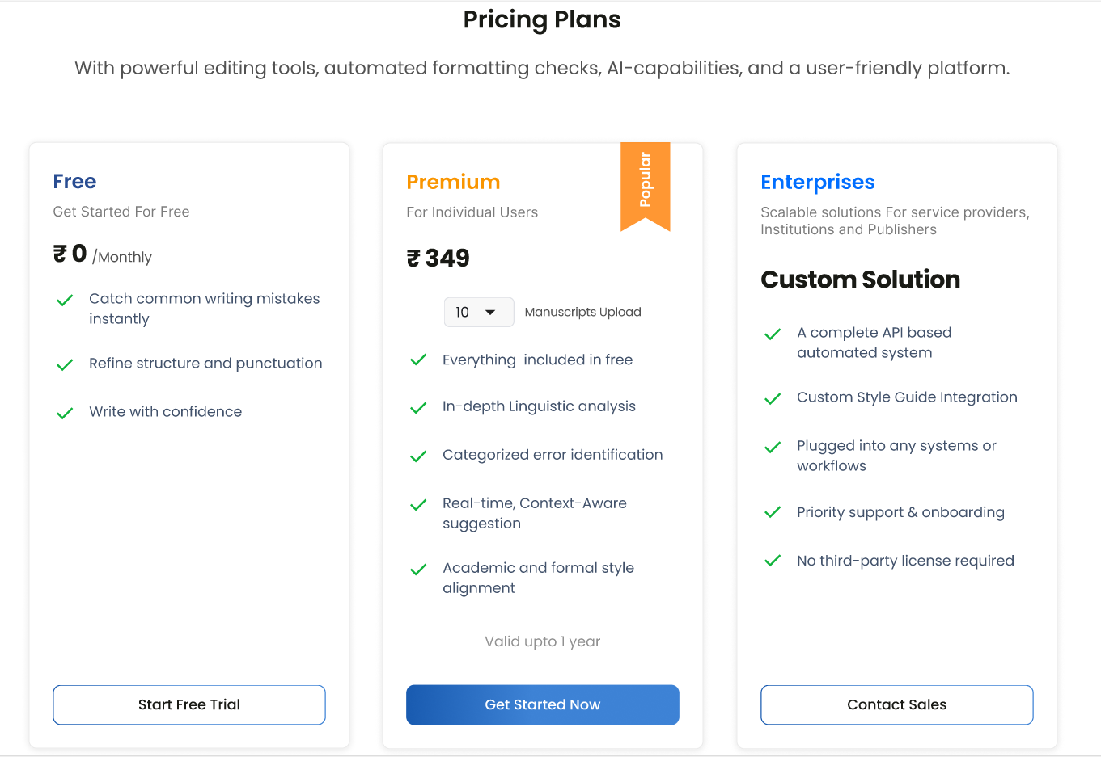
My Accounts:
Keep it similar to PaperPerfect.

