QA testing feedback
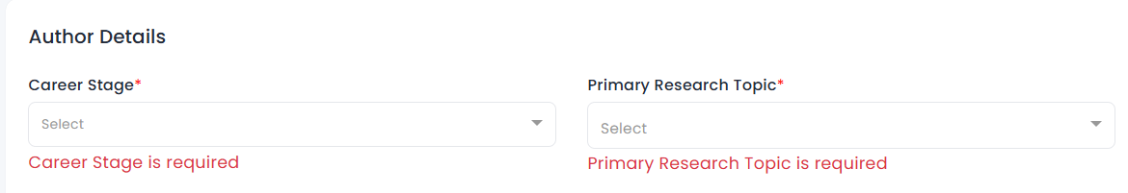
There are numerous dropdown options available for career stage and primary research topic. I’ve reshared the list in the group—please refer to it and ensure it’s added here.
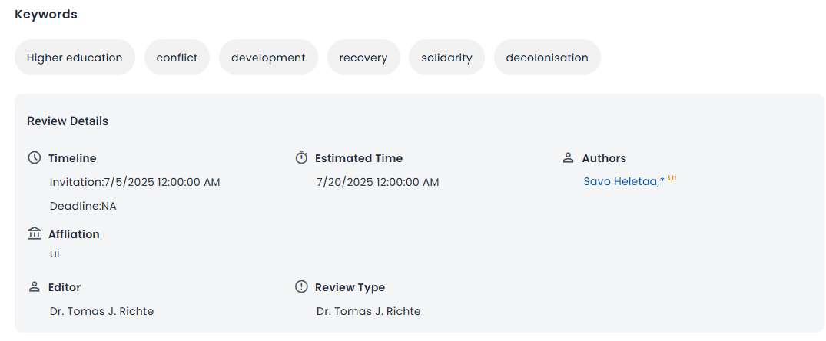
Please update the information based on the provided package. Refer to the manuscript and metadata details to ensure the on-screen information is accurate.
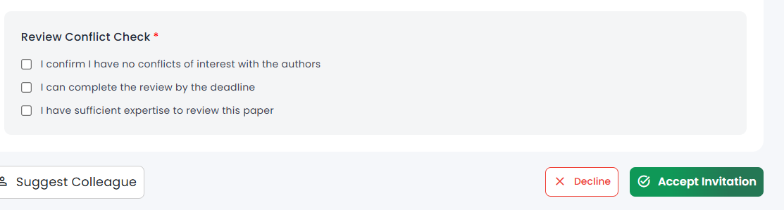
The size of the "Suggest Colleague" button is noticeably larger than the "Decline" and "Accept Invitation" options. Please adjust its size to maintain consistency.
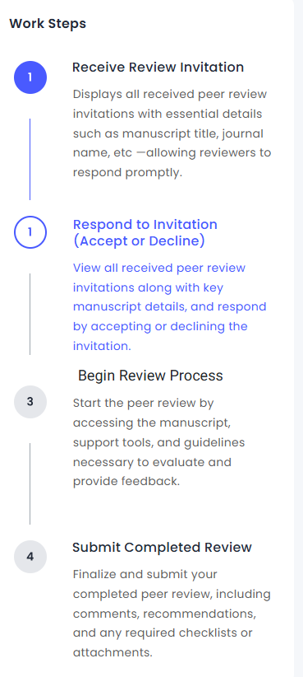
We are not changing the content color—only the color of the step numbers (i.e., 1, 2, 3...) needs to be updated.
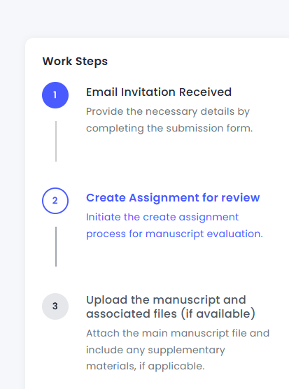
The same applies to the worksteps in the "Create Assignment" section—only the color of the step numbers needs to be updated, not the content color.
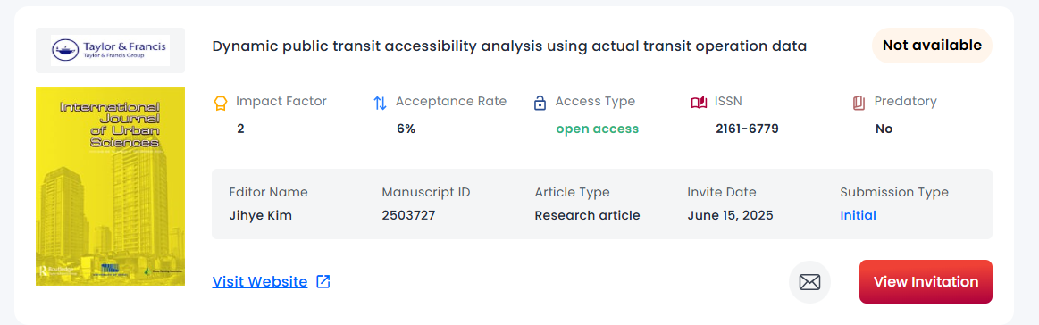
Once click on visit website we should redirect to journal website page.
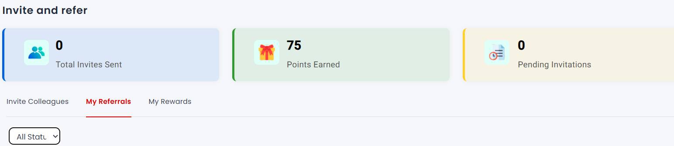
All status option should be display clearly.

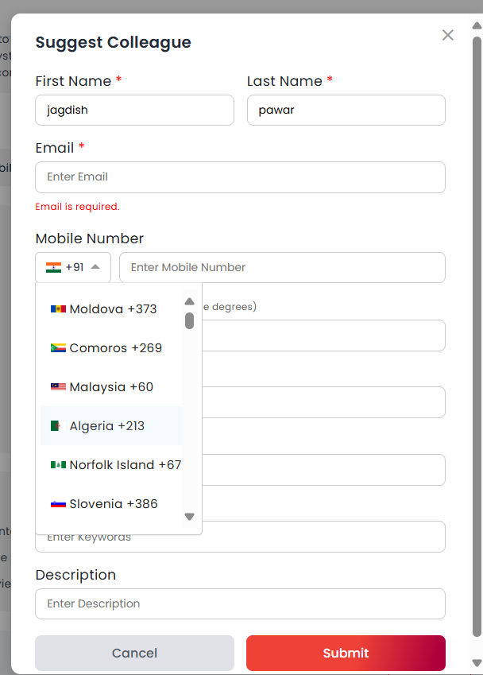
While suggesting a colleague the flag under country only the first country flag should be display before selecting any.
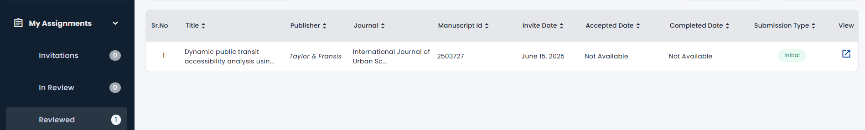
Once the invitation is accepted and click on start review the invitation should go under in review not reviewed.
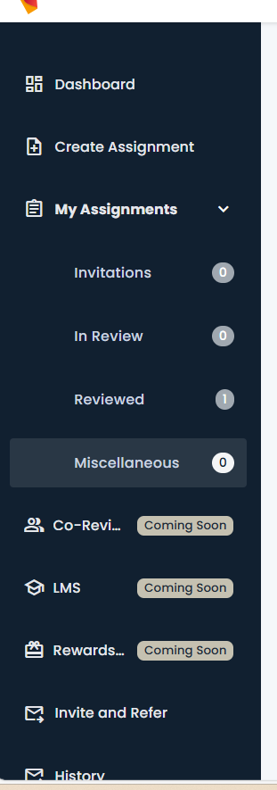
Need to add scrollbar here – left sidebar options to view and access all the features.
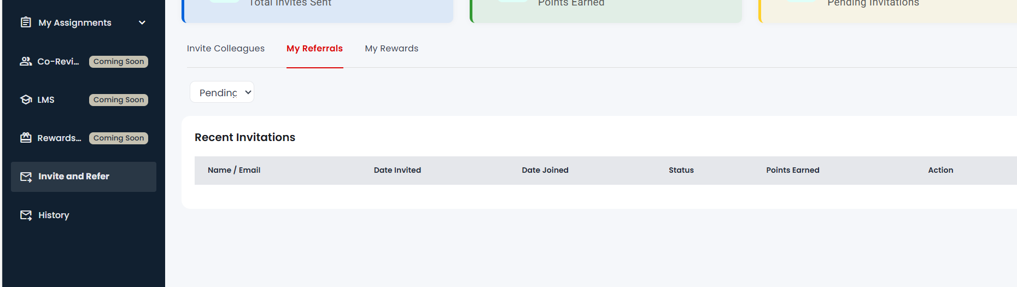
Once we have sent invite to someone it should be display in the list below the recent invitations along with the status.
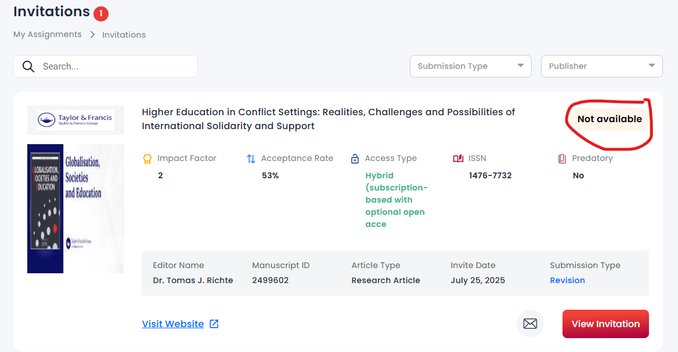
No need to show not available option here.
Update the cover page images update with the updated images recently provided by Jagdish.

