The Art of Workplace Happiness: Developing a Buddhist-Inspired Employee Sustainability Scale

Abstract
The research endeavor is dedicated to examining the employee sustainability (ES) practices among manufacturing companies. Given the variability of ES practices across emerging nations, this investigation established a comprehensive scale of ES metrics through a meticulous two-phase process of scale construction and validation, drawing upon environmental, social, and governance (ESG) indexes, happiness indexes, Buddhist philosophical tenets, and an extensive review of pertinent literature. Subsequently, the proposed framework, which illustrates the physical and psychological dimensions of ES, was empirically evaluated utilizing a mixed-method validation approach combining SmartPLS and Python. The convergence of results across both platforms ensured methodological rigor and enhanced the reliability and consistency of the scale. A multi-faceted method that incorporated both qualitative & quantitative analyses involving 900 employees from manufacturing organizations facilitated the validation of the formative construct of ES, encapsulated through eight dimensions: egalitarianism (EG), health and safety (H&S), human rights (HR), learning and development (L&D), cultural enrichment (CE), governance (GV), philanthropy (PL), and psychological well-being (PW). The results substantiated the significant influence of ES practices within manufacturing organizations in India on employee well-being. The study elucidates both theoretical and practical implications.

Keywords: Employee sustainability; Happiness; Well-being; Consumer; Formative measurement model; Scale development

1 Introduction
With the swift socio-economic transformation, organizations across the globe have witnessed a remarkable growth trajectory over the recent decades. However, this extensive globalization has also engendered a market environment with intense competition, results significant pressures on organizations to prioritize shareholder profit (Friedman, 1970). The trend has often sidelined the real factors contributing to stakeholder happiness, shaping corporate missions and values accordingly (Kennerley & Neely, 2002). This corporate objective has emerged as a predominant influence in shaping market regulations with a redirected focus toward immediate gains, thereby jeopardizing long-term value. The organizational framework has evolved to such an extent that sustaining productivity while adhering to deadlines fosters an environment of relentless pressure. Empirical evidence further suggests that this competitive landscape is propelling organizations towards expedited hiring and firing practices, superficial commitments to purpose (Purpose and Connection) and culture, and fostering an illusion of a supportive work environment, thereby exacerbating employees' stress and deteriorating well-being (Gallup, 2023).
“The world is becoming unhinged, and employees’ well-being is rapidly declining during a golden era of progress and prosperity, which presents one of the greatest paradoxes of our time,” articulated by United Nations Secretary-General António Guterrez and Harvard Professor Steven Pinker. The decline in well-being can be connected to the sudden surge in job disengagement, culminating in increased unemployment. Both supply-side and demand-side variables have contributed to this surge. Job-seeking activity within the corporate realm has escalated swiftly, indicating heightened demand. On the supply side, there has been an uptick in hiring practices attributable to organizations' rapid hiring and firing policies. In conjunction with aggressive market penetration and predatory pricing strategies, organizations have undergone a paradigm shift towards cost-reduction initiatives. This shift predominantly inflicts suffering upon the organization’s foundational element (employees), manifesting in culture washing and the fulfilment of only the most minimal employee value propositions to mitigate organizational costs. Consequently, predatory pricing has emerged as one of the most influential systemic catalysts reshaping the organizational landscape globally, causing psychological distress, and disengagement among employees (Human Development Report, United Nations Development Programme, 2024). Alarmingly, employee disengagement is impeding global economic growth, costing $8.8 trillion-9% of GDP— potentially jeopardizing human success (Gallup, 2023). Despite spending 81,396 hours at work, 60% of the workforce is remaining emotionally detached & disengaged at workplace (Gallup, 2024). Disengagement is particularly pronounced in sectors with highly routinized tasks, like manufacturing, where traditional management often prioritizes processes over personnel, fostering aversion toward employment. Experiencing employment that one finds undesirable is significantly more detrimental than the state of unemployment; furthermore, these adverse emotional states invariably permeate domestic life, thereby affecting familial relationships (Helliwell et. al, 2024).
India bears 14% of the global mental health burden, costing an annual economic loss of US$14 billion (Deloitte, 2022; Gallup, 2022). The COVID-19 pandemic has worsened employment conditions for 0.61 billion employees, particularly affecting 35.65 million in manufacturing (ILO, 2024; Statista, 2023). Stress and anger in the workforce have reached unprecedented levels, with India ranking 126th out of 143 nations in overall happiness (Helliwell, 2024). Additionally, 52% of employees are contemplating a job change, and 32% are disengaged, contributing to organizational layoffs and resignations, impacting India's socio-economic landscape (Gallup, 2024; Mint, 2022). This creates challenges for organizations, affecting their reputation, economic health, and appeal to future generations.
The contemporary labor market sees millennials and Generation Z strong inclination towards transformative change, desiring engagement on emotional and behavioral levels (Anicca) and job security more than previous generations. As this demographic are entering the workforce and baby boomers are retiring, the power dynamics between employees and organizations are shifting. The concept of organizations-as-a-service and employees-as-consumers/resources are becoming popular (Ng & Forbes, 2009). Within this evolving paradigm, organizations (providers) offer employment opportunities to employees, who in turn accept these roles (consumers) and reciprocate with their time and labor (resources) to facilitate production and overall organizational success. As employees increasingly recognize their pivotal part in organizations’ success, the equilibrium of power is transitioning from job providers (organizations) to consumers/resources (employees). This demographic has begun to view employee well-being and its associated outcomes as an intrinsic right. Consequently, this consumer-oriented perspective compels organizations to adopt a more employee-centric approach, recognizing the importance of employee well-being in attracting and retaining talent. In order to contend effectively within this highly competitive landscape for talent, organizations must distinguish themselves through a comprehensive vision of employee well-being. Moreover, similar to Buddhist principles of happiness, adherence to sustainable development objectives, workplace experiences, positive organizational culture, and compassion in governance (Metta), alongside cultural and spiritual values are crucial for achieving happy workplace & get recognition as the "Best Employer." The persistent inability to secure satisfactory employment may result in enduring economic stagnation.
1.1 Research Gaps
While consumerism may have hindered well-being, it has also driven organizations to prioritize employee welfare, linking sustainability with consumer satisfaction. Rising consumer interest in concepts like Buddhist happiness principles and positive workplace environments has gained media attention, prompting some companies to appoint Chief Well-being or Happiness Officers. Mick (2006) highlighted the need for research enhancing employee well-being, aligning with calls to integrate positive psychology into organizational strategies. Thus, organizations must first understand employee well-being to effectively serve consumers.
However, well-being remains complex, evolving, and vaguely defined (Travia et al., 2020). Literature reveals gaps, including minimal adaptation of ES frameworks for happiness, narrow theoretical foundations in SS, and limited focus on employee perspectives in emerging economies' manufacturing sectors. There is also a lack of validated tools to measure ES effectively.

2 Literature Review
2.1 Different Social Sustainability
Social Sustainability (SS) lacks a universally accepted definition and spans various dimensions, including corporate social responsibility (CSR), green human resource management (HRM), supply chain SS, and sustainable HRM. To understand SS, it is essential to address three key questions: Who is the target audience? What specific problems are being tackled? And how are these problems being resolved? (Supplementary Table 1)
The first dimension is corporate social responsibility (CSR), which involves businesses voluntarily addressing social and environmental challenges in their operations and stakeholder interactions. Carroll’s pyramid model (1999) outlines CSR in terms of legal, economic, philanthropic, and ethical responsibilities. Various studies have contextualized CSR within stakeholder theory and sustainable development frameworks. Research shows CSR can positively impact corporate financial performance and HR practices, with HR professionals in Europe prioritizing economic outcomes, except in Switzerland (Zaugg et al., 2001). The second dimension, green HRM, integrates sustainability into HR practices such as green training, hiring, and compensation. This dimension aims to enhance employees’ ecological awareness and reduce carbon emissions, contributing to sustainable organizational success. Green HRM is aligned with strategic HRM and helps attract and retain talent through environmental initiatives (Renwick et al., 2016). The third dimension focuses on supply chain SS, which entails managing diverse flows across enterprises aligned with sustainable development goals. Key factors in supply chain SS include philanthropy, equity, health & safety, human rights, labor issues, and product accountability, particularly in emerging markets. Studies have highlighted issues like worker quality of life and rights in sectors such as apparel (Huq et al., 2016) and oil and gas (Silvestre, 2015). The fourth dimension evaluates SS from a financial perspective, linking it to organizational performance. HRM is shown to improve performance through social outcomes, productivity, and reduced turnover, although HR managers face challenges in demonstrating financial contributions and balancing labor costs with employee well-being (Majjhima Patipada). Scholars emphasize the need for a paradigm shift in HR practices toward long-term success and prioritizing employee outcomes (Wilkinson et al., 2001). The fifth dimension, Sustainable HRM, involves long-term strategies for socially and economically responsible employee management. This dimension prioritizes flexibility, commitment, and collaboration in HR practices, with an emphasis on improving efficiency and employee well-being. Research also focuses on sustainable work systems, leadership, and international HRM (Ehnert, 2011; Avery & Bergsteiner, 2010). The concept of Common Good HRM has emerged, addressing human rights and sustainability concerns, particularly in relation to in-work poverty and youth unemployment (Aust et al., 2020).
Several impact assessment tools have been developed to evaluate corporate social responsibility, including general-purpose and domain-specific frameworks. The United Nations has established guidelines for social impact assessments, such as the Principles for Responsible Investment and the Social Return on Investment framework, which focus on reducing environmental harm and enhancing social benefits (Banke-Thomas et al., 2015). Social accounting tools like the Global Reporting Initiative (GRI) help corporations communicate their HR initiatives (Ehnert et al., 2016). However, ESG reports often focus on compensation and demographic information, neglecting critical questions about whether employees are treated with dignity or feel valued.
In conclusion, Social Sustainability encompasses several interconnected dimensions, from CSR and green HRM to supply chain sustainability and HR policies’ impact on financial performance. Future research should refine assessment tools and frameworks to better capture the broader impact of SS on employee well-being and societal sustainability.
2.2 Buddhist Principles on Happiness
Research on holistic well-being and quality of life, rooted in Buddhist principles like mindfulness (Sati) and compassion (Metta), is gaining traction (Table 1). Frameworks like Gross National Happiness (GNH) assess life quality beyond material wealth, emphasizing balanced progress across spiritual, cultural, social, and ecological dimensions (Ura, 2009). Happiness, deeply linked to work, shapes identity and life satisfaction (Mesmet-Magnus & Viswesvaran, 2005). Both tangible factors (e.g., pay, benefits) and intangible ones (e.g., relationships, work-life balance) influence employee happiness across five life domains (Ura, 2012). Studies also link happiness to productivity and organizational performance (Oswald et al., 2015).
Despite this, organizations often treat employees as mere resources, especially in manufacturing sectors, where employee-centric research is scarce. A consumer-oriented approach, guided by Buddhist happiness philosophies, is needed to develop an “employee consumer” framework. A bibliometric review found only 31 studies on "employee sustainability," with limited contributions from India and minimal integration of happiness-related terms (Supplementary Table 2) (Figure1, 2 , 3). No validated scale currently measures employee sustainability, highlighting a critical gap. Future efforts should focus on promoting well-being through both material and non-material means to support sustainable development.
Table 1: Buddhist Philosophies of Happiness
Philosophies | Meaning
Sati | Mindfulness
Samma Ajiva | Right Livelihood
Metta | Compassion and Loving-Kindness
Flexibility | Adaptability and openness
Upekkha | Equanimity
Majjhima Patipada | The Middle Way
Anicca | Impermanence
Sila | Ethical Conduct
Purpose and Connection | Sense of purpose

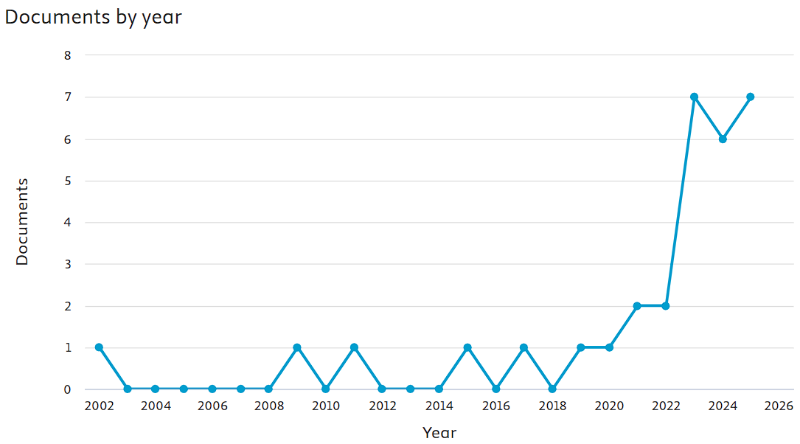
Figure 1: Annual Publication of ES Documents
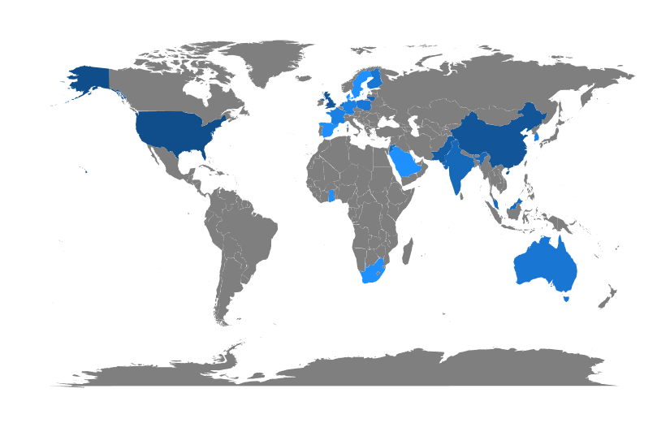
Figure 2: World Map based on Publications till April 2025
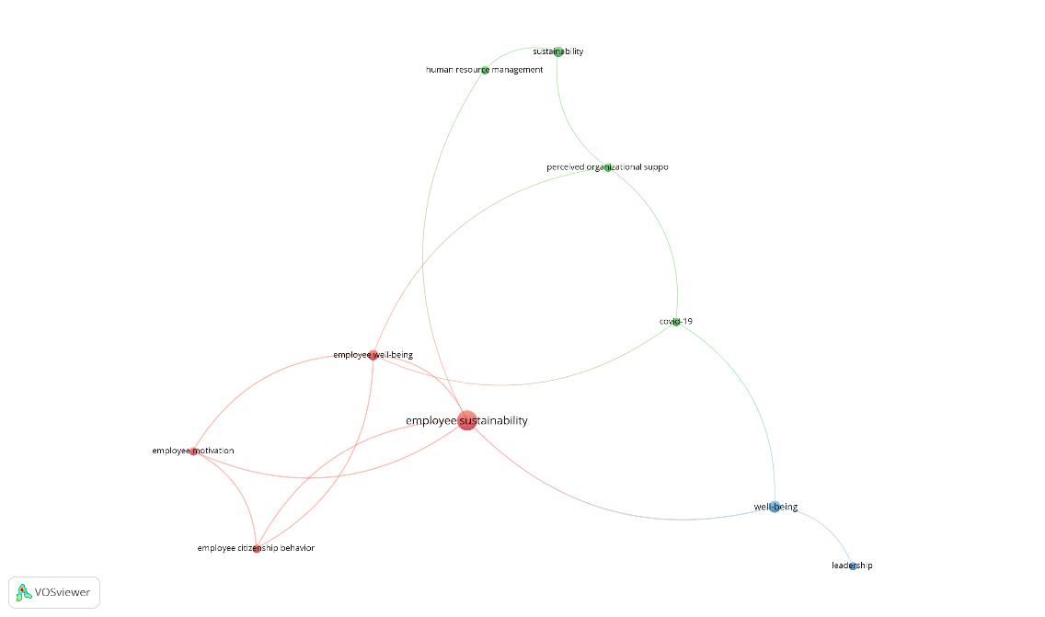
Figure 3: Co-occurrence of Authors’ Keywords

3. Methodology
The research follows a two-phase empirical approach (Figure 4). Phase one involves developing and pretesting an item pool based on Thornton et al.'s (2013) ES framework. Phase two includes a quantitative assessment via an online survey. The study evaluates both first-order and second-order formative models using PLS-SEM in SmartPLS 4.0, suitable for complex, predictive models in social sciences (Hair et al., 2022). PLS-SEM is preferred over CB-SEM for handling formative constructs and multiple measurement constraints (Rigdon et al., 2017). Python 3.12.2 is also used to strengthen the validation process, ensuring greater robustness.

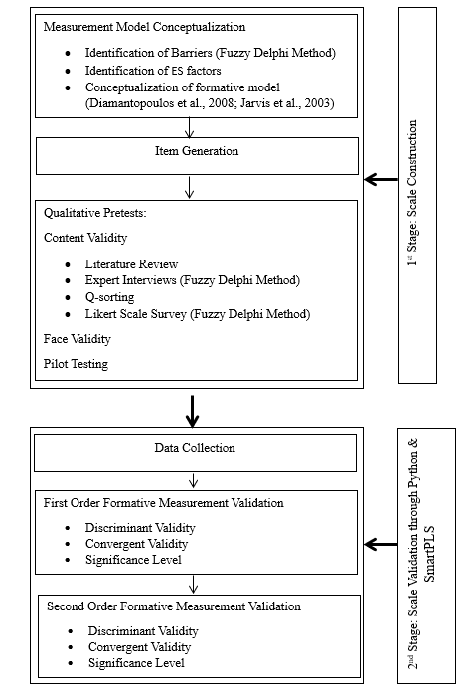
Figure 4. Two-stage Scale Development Process

3.1. Stage 1: Scale Construction
3.1.1. Measurement Model Conceptualization
The research design is structured in three phases. In the first phase, fifteen barriers related to the Employee Sustainability (ES) construct were identified through literature reviews, expert interviews (with sustainability and HR managers), and surveys using a nine-point Likert scale. Next, an analysis of various sustainability frameworks, including the GRI report, Buddhist philosophies, the GNH index, and the World Happiness Report, was conducted to pinpoint specific domains related to ES.
In the second phase, ES is conceptualized as a formative second-order construct composed of eight first-order constructs: egalitarianism (Upekkha), health and safety, human rights, learning and development, cultural enrichment, governance, philanthropy, and psychological well-being (Figure 5). The measurement model is a Type IV formative–formative model, which captures important conceptual distinctions through hierarchical abstraction (Mackenzie et al., 2005). This model aligns with frameworks by Petter et al. (2007) and tackles debates about the validity of formative models, drawing on the perspectives of Diamantopoulos & Winklhofer (2001) and Wilcox et al. (2008), who argue that constructs like ES are formative in nature. According to Bollen & Bauldry (2011), indicators must have a causal influence on the latent variable, and any change in indicators will modify the latent variable.
In the third phase, the model follows Bollen & Lennox’s (1991) framework, where each first-order construct consists of multiple variables that contribute independently to the aggregate. These constructs include unique employee value propositions, and their omission would change the interpretation of the overall ES construct. The framework asserts that each dimension of ES is critical for employee well-being, and changes in any dimension, such as egalitarian practices, could impact outcomes like retention intentions.
The model challenges traditional views on formative vs. reflective measures, supporting the idea that formative indicators are causal, non-interchangeable, and may not covary with the construct. This sensitivity to outcome variables suggests that formative measures may vary depending on the context (Wilcox et al., 2008), requiring empirical testing for consistency across different outcomes (Bollen & Bauldry, 2011). Comprehensive empirical validation is essential for future research to confirm the validity of the proposed measurement model.
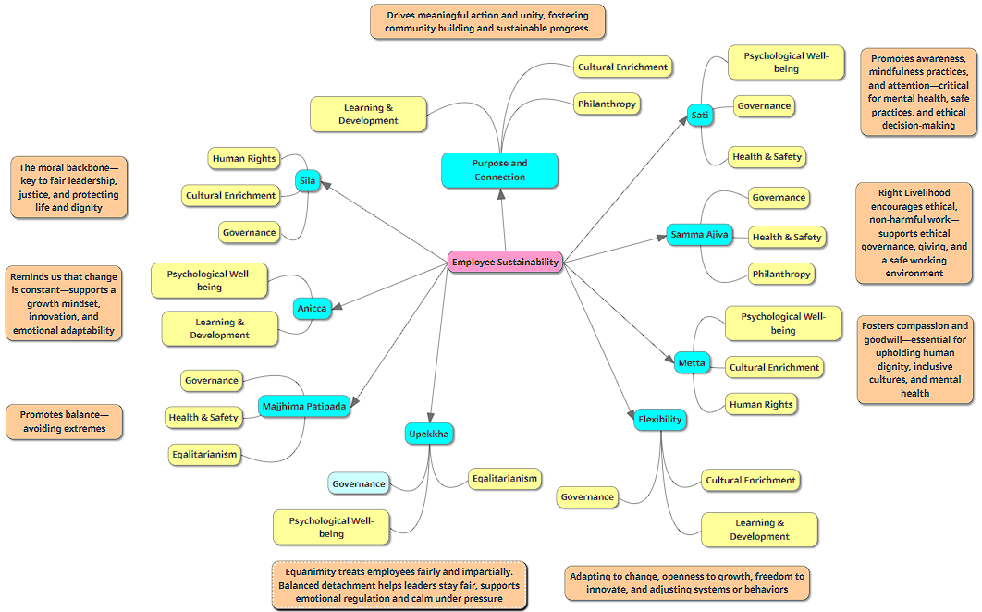
Figure 5. Mind mapping of Employee Sustainability Factors based on Buddhist principles
3.1.2. Item generation
To operationalize the first-order measurement models utilizing formative indicators, a structured scale development process is employed, beginning with the generation of measurement items which encapsulate the essential elements of each first-order construct to create a comprehensive item pool. The initial pool yielded a preliminary inventory of 39 measurement items across 8 dimensions of ES, derived from an extensive literature review. Special emphasis was placed on the clarity of the indicators. At this juncture, it is imperative to establish the content validity of generated items, which subsequently enhance the overall construct validity (Peter, 1981).
3.1.3. Qualitative Pretests
A five-step qualitative pretest was conducted to validate the ES construct and its measurement items. Content validity was ensured through method triangulation—literature review, expert interviews, and surveys—and investigator triangulation. Q-sorting and expert input clarified the eight ES dimensions, with 15 experts (each with 10+ years of experience) participating in Fuzzy Delphi interviews until saturation. Their feedback refined the items to 41.
Next, Q-sorting interviews were analyzed using NVivo 12 with thematic and axial coding. Inter-coder reliability yielded a strong Kappa score of 0.82 and 97.72% agreement. Overlapping codes were merged to enhance clarity. The Fuzzy Delphi method further validated 32 sub-factors and eight main factors, based on a cutoff of 60.179.
In the fourth phase, five senior HR and OB academics confirmed face validity, suggesting wording refinements. Finally, a pilot test with 30 experienced employees from Indian manufacturing firms helped finalize a 32-item scale for large-scale deployment.
3.2. Stage 2: Scale Validation
An online survey was conducted, & the resultant data were subjected to a number of validation assessments, particularly to determine whether ES is optimally characterized as a formative second-order construct encompassing eight formative first-order constructs. The classification of ES as a higher-order construct necessitates that the measurement evaluation to be conducted at two distinct levels. Initially, at the first-order construct level, the proposed interrelations among the first-order constructs and the second-order construct must be evaluated in terms of their “significance and strength”. We adhere to the assessment procedures for formative measurement models as delineated by Diamantopoulos & Winklhofer (2001) and Mackenzie et al. (2005). Subsequently, identical procedures were applied at the second-order construct level.
3.2.1. Data Collection
The survey included two sections: demographics and 32 ES-related items (Table 2). To ensure response quality, two attention-check questions and reverse-coded items were added (Meade & Craige, 2012). Responses failing attention checks or incomplete were excluded. The questionnaire also contained scales for assessing nomological validity and was distributed electronically via Google Forms and in print across manufacturing organizations in eastern India from August to February 2025.
Out of 1360 responses, 900 were valid (23% response rate) after excluding low-variance and inattentive responses. A seven-point Likert scale was used. Table 3 summarizes demographics: 29% from public and 71% from private sector units. Most had under 5 years (32.33%) or 5–10 years (27.44%) of experience. Female respondents made up 56.33%, and the largest age group was 21–30 years (33.44%). Most participants worked in Quality (23.44%) and Cold Rolling Mill (16.88%) departments.

Table 2: ES Dimensions & Items
Concept | Dimensions | Items | Description
Organizational Social Sustainability (OSS) | Egalitarianism (ER) | Gender Equality (ER1) | Getting treated fairly with different sexual orientation
Organizational Social Sustainability (OSS) | Egalitarianism (ER) | Equal Opportunity (ER2) | Having the same opportunities for employment, promotion, work
Organizational Social Sustainability (OSS) | Egalitarianism (ER) | Diversity (ER3) | Getting treated fairly with a different range of characteristics, such as religion, race, age, ethnicity, education
Organizational Social Sustainability (OSS) | Egalitarianism (ER) | Equal Remuneration (ER4) | Having the same salary
Organizational Social Sustainability (OSS) | Health & Safety (H&S) | Working Conditions (H&S1) | Getting all degree of safety, non-hazardous workplace, cleanliness, space, lighting, and temperature
Organizational Social Sustainability (OSS) | Health & Safety (H&S) | Women Safety (H&S2) | Having sexual harassment policy, POSH & POSCO training, complaints committee, safe working environment
Organizational Social Sustainability (OSS) | Health & Safety (H&S) | Welfare Provisions (H&S3) | Having facilities such as a washing area, canteen, children's room, medical facilities, sitting arrangement, locker room, etc
Organizational Social Sustainability (OSS) | Human Rights (HR) | Laws Awareness Training (HR1) | Having training regarding different human rights, and learning about the importance
Organizational Social Sustainability (OSS) | Human Rights (HR) | Child Labor (HR2) | Use of children (below 14 years) as workers, servants, and apprentices, which impacts their physical and mental development
Organizational Social Sustainability (OSS) | Human Rights (HR) | Indigenous Rights (HR3) | Minimum standards for the survival, dignity & well-being of the native peoples, existing human rights standards & their fundamental freedoms
Organizational Social Sustainability (OSS) | Human Rights (HR) | Freedom of Association & Collective Bargaining (HR4) | Freedom to form associations, or unions/ Employees, through their unions, can negotiate contracts with their employers to determine their terms of employment.
Organizational Social Sustainability (OSS) | Culture Enrichment (CE) | Ethics & Values (CE1) | Having a culture that influences the moral judgment of employees & has a robust ethical culture & values to motivate them to work with honesty & integrity
Organizational Social Sustainability (OSS) | Culture Enrichment (CE) | Cultural Programs (CE2) | Celebration of different festivals & important occasions in the organization
Organizational Social Sustainability (OSS) | Culture Enrichment (CE) | Way of Harmony (CE3) | Working together in a peaceful manner; workplace culture like attitude towards manager; adaption of changes like technology, western culture
Organizational Social Sustainability (OSS) | Learning & Development (L&D) | Creativity (L&D1) | Encouraging creative & innovative process
Organizational Social Sustainability (OSS) | Learning & Development (L&D) | Performance Management (L&D2) | Communicating & clarifying job responsibilities, performance expectations, & development planning that optimize an employee's performance
Organizational Social Sustainability (OSS) | Learning & Development (L&D) | Knowledge about Company (L&D3) | Getting training to align employees' personal goals with the organization's mission & vision to reach the organizational goals
Organizational Social Sustainability (OSS) | Learning & Development (L&D) | Career Development (L&D4) | Getting support for professional growth, to employees' movement to a new position or project
Organizational Social Sustainability (OSS) | Governance (GV) | Employment (GV1) | Governing the living standard of employees, managing employment
Organizational Social Sustainability (OSS) | Governance (GV) | Anti-Corruption (GV2) | Having a zero-tolerance policy on bribery & corruption
Organizational Social Sustainability (OSS) | Governance (GV) | Freedom (GV3) | Having the freedom to speak, vote, or join any party
Organizational Social Sustainability (OSS) | Governance (GV) | Transparency (GV4) | Having transparent workplace
Organizational Social Sustainability (OSS) | Governance (GV) | Grievance Redressal & Audit (GV5) | Receipt and processing of complaints from employees
Organizational Social Sustainability (OSS) | Philanthropy (PL) | Awareness Training (PL1) | Getting training regarding different social activities & its impact on society
Organizational Social Sustainability (OSS) | Philanthropy (PL) | Community Wellbeing (PL2) | Taking responsibility towards society like education, women empowerment, skill development, etc
Organizational Social Sustainability (OSS) | Philanthropy (PL) | Ecological Contribution (PL3) | Taking responsibility towards the environment, ecological issues, and wildlife
Organizational Social Sustainability (OSS) | Psychological Well-being (PW) | Accomplishment & Recognition (PW1) | Getting awards based on the performance
Organizational Social Sustainability (OSS) | Psychological Well-being (PW) | Spirituality (PW2) | Having a deliberate state of spiritual calm with a positive mind
Organizational Social Sustainability (OSS) | Psychological Well-being (PW) | Work-Life Balance (PW3) | Having time & flexibility for both work & personal life
Organizational Social Sustainability (OSS) | Psychological Well-being (PW) | Employee Management Relation (PW4) | Maintain a positive relationship with the employees
Organizational Social Sustainability (OSS) | Psychological Well-being (PW) | Emotional Balance (PW5) | Having a deliberate state of positive emotions
Organizational Social Sustainability (OSS) | Psychological Well-being (PW) | Job Security (PW6) | Knowing that the job is safe from being cut & assurance for the foreseeable future

Table 3: Profile of the Participants
Category |  | Frequency | Percentage (%)
Gender | Male | 507 | 56.33
 | Female | 383 | 42.55
 | Other | 10 | 1.11
Age | 21-30 | 301 | 33.44
 | 31–40 | 270 | 30
 | 41–50 | 160 | 17.77
 | 51–60 | 169 | 18.77
Year of Work Experience | ≤5 years | 291 | 32.33
 | 5-10 years | 247 | 27.44
 | 10-15 years | 143 | 15.88
 | >15 years | 219 | 24.33
Department | Human resources | 148 | 16.44
 | Finance & Accounts | 96 | 10.66
 | Corporate Social Responsibility | 31 | 3.44
 | Quality | 211 | 23.44
 | Blast & Furnance | 126 | 14
 | Slabbing Mill | 78 | 8.66
 | Hot Strip Mill | 58 | 6.44
 | Cold Rolling Mill | 152 | 16.88
Type of Company | Public Sector Unit | 261 | 29
 | Private | 639 | 71

3.2.1.1. Assessing Bias
Harman’s single-factor test was applied to address common method bias. Since no single factor accounted for more than 50% of the variance, common method bias was not a concern (Podsakoff et al., 2003). To check nonresponse bias, early and late responses were compared (Armstrong & Overton, 1977). As all p-values exceeded 0.05 (lowest being 0.065), no significant differences were found, indicating nonresponse bias was not present.
A two-step disjoint indicator approach was adopted to assess the formative hierarchical model, as recommended for such constructs (Duarte & Amaro, 2018).
3.2.2. First-Order Measurement Validation
Fundamental evaluations for any formative measurement model encompass three processes: discriminant validity (collinearity), convergent validity (redundancy analysis), and significance level.
Initially, discriminant validity was examined. A crucial step in evaluating a formative measurement model involves examining multicollinearity among its indicators, as it reflects the degree of correlation between two or more independent variables. Given that formative models are based on multiple regression techniques, high collinearity can distort the estimation of indicator weights and their statistical significance (Hair et al., 2017). In this study, all Variance Inflation Factor (VIF) values, calculated using both Python and SmartPLS, ranged between 1.07 and 4.08—well below the recommended threshold of 5 (Petter et al., 2007). This indicates that multicollinearity is not a concern for the formative indicators of the construct (Table 4) (Figure 6).
Following this, the outer weights and their statistical significance were examined. Bootstrapping with 5,000 resamples was employed to evaluate the significance of the outer weights (Hair et al., 2017). This non-parametric technique involves repeatedly drawing samples with replacement from the original dataset, based on the assumption that such resampling closely approximates the true population distribution (Good, 2006). The outer weight values are standardized, thereby facilitating comparative analysis among them. Following the analysis (Table 4; Figure 7), it was determined that each indicator's t-statistics, p-values, outer weights, and outer loadings (threshold limit 0.5) were more than the threshold limit and significant at p 0.001 (Hair et al., 2013). A significant p-value with consistent positive outer weights in both Python and SmartPLS confirms the robust contribution of each indicator, reinforcing the stability and credibility of the formative construct’s structure.
Third, the nomological validity (convergent validity) was employed to examine the interrelationships among the constructs (Hair et al., 2010). It is imperative that the number of non-redundant elements in the covariance matrix of the observed variables is equal to or greater than the number of unknown parameters in the model, and that the latent constructs are properly scaled, in accordance with the scaling rule. Among the various scaling approaches available, this study adopted the strategy of using a single reflective indicator along with a reflective measurement construct as the outcome variable (Diamantopoulos et al., 2008). Diamantopoulos & Winklhofer (2001) advocated for the inclusion of a global measure that encapsulates the essence of the entire construct. A specific reflective indicator of all 8 constructs like (H&SGV – As an employee, I am satisfied with my health & safety at organization) has been utilized as a global measure to mitigate the challenges associated with under-identification and to facilitate validation efforts. The correlation coefficients among the eight factors were recorded as 0.956, 0.847, 0.960, 0.964, 0.925, 0.887, 0.911, and 0.892 all of which surpassed the recommended threshold of 0.70 (Hair et al., 2017) and were statistically significant at the 0.01 level. These findings corroborate the nomological validity of the measurement model (Figure 8).

Table 4: Discriminant Validity and Significance Level of the First-Order Constructs
First-Order Constructs | Outer Weight | Outer Loading | T Statistics | P Values | VIF
HR1 -> HR | 0.389 | 0.771 | 20.175 | 0 | 1.427
HR2 -> HR | 0.301 | 0.74 | 15.671 | 0 | 1.427
HR3 -> HR | 0.368 | 0.78 | 19.303 | 0 | 1.462
HR4 -> HR | 0.313 | 0.612 | 17.479 | 0 | 1.168
H&S1 -> H&S | 0.454 | 0.738 | 25.084 | 0 | 1.19
H&S2 -> H&S | 0.449 | 0.761 | 24.33 | 0 | 1.235
H&S3 -> H&S | 0.453 | 0.714 | 25.837 | 0 | 1.142
GV1 -> GV | 0.344 | 0.654 | 11.872 | 0 | 1.245
GV2 -> GV | 0.28 | 0.59 | 9.847 | 0 | 1.22
GV3 -> GV | 0.352 | 0.62 | 11.916 | 0 | 1.214
GV4 -> GV | 0.291 | 0.551 | 10.149 | 0 | 1.194
GV5 -> GV | 0.367 | 0.632 | 12.781 | 0 | 1.139
CE1 -> CE | 0.415 | 0.806 | 15.388 | 0 | 1.437
CE2 -> CE | 0.383 | 0.756 | 13.924 | 0 | 1.33
CE3 -> CE | 0.46 | 0.817 | 16.496 | 0 | 1.39
PL1 -> PL | 0.501 | 0.755 | 30.534 | 0 | 1.174
PL2 -> PL | 0.475 | 0.759 | 26.732 | 0 | 1.199
PL3 -> PL | 0.419 | 0.623 | 27.657 | 0 | 1.07
PW1 -> PW | 0.131 | 0.689 | 7.515 | 0 | 1.642
PW2 -> PW | 0.21 | 0.731 | 10.538 | 0 | 1.596
PW3 -> PW | 0.251 | 0.78 | 12.192 | 0 | 1.746
PW4 -> PW | 0.226 | 0.756 | 10.925 | 0 | 1.665
PW5 -> PW | 0.235 | 0.804 | 10.99 | 0 | 1.915
PW6 -> PW | 0.246 | 0.818 | 10.38 | 0 | 2.066
EG1 -> EG | 0.297 | 0.761 | 12.568 | 0 | 1.61
EG2 -> EG | 0.405 | 0.781 | 18.805 | 0 | 1.454
EG3 -> EG | 0.285 | 0.786 | 13.194 | 0 | 1.692
EG4 -> EG | 0.352 | 0.664 | 18.918 | 0 | 1.225
L&D1 -> L&D | 0.348 | 0.75 | 18.071 | 0 | 1.458
L&D2 -> L&D | 0.302 | 0.76 | 15.784 | 0 | 1.543
L&D3 -> L&D | 0.331 | 0.706 | 19.067 | 0 | 1.307
L&D4 -> L&D | 0.36 | 0.764 | 20.194 | 0 | 1.398

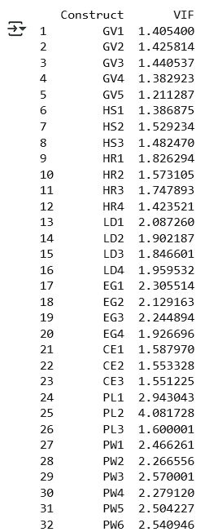
Figure 6: VIF of First-Order Constructs by Python

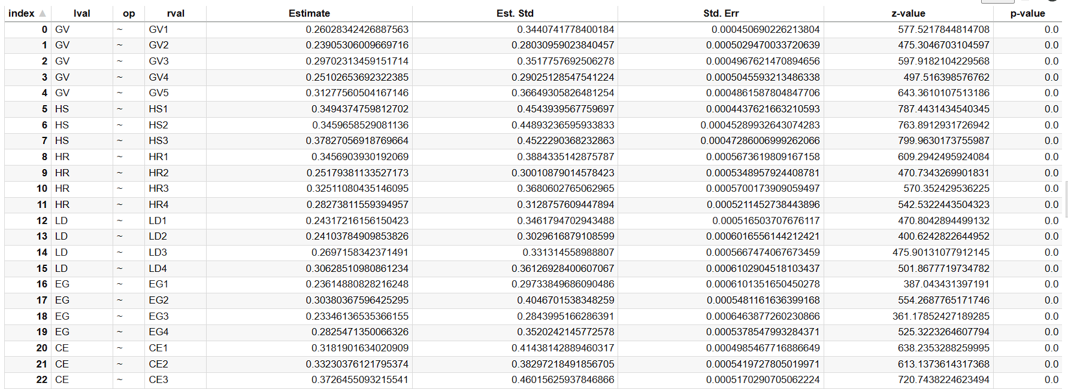
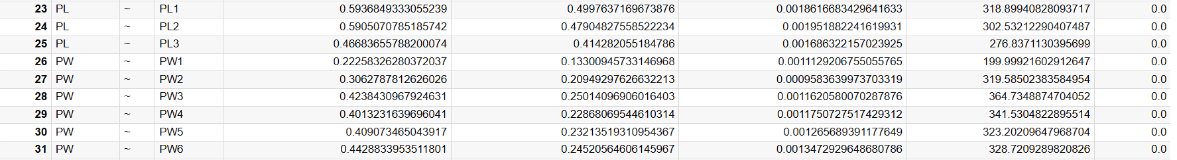
Figure 7: Outer Weight & P-value of First-Order Constructs by Python

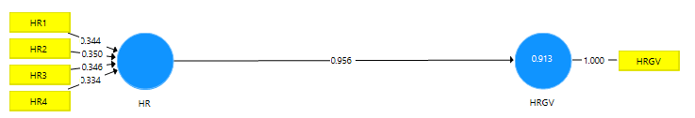
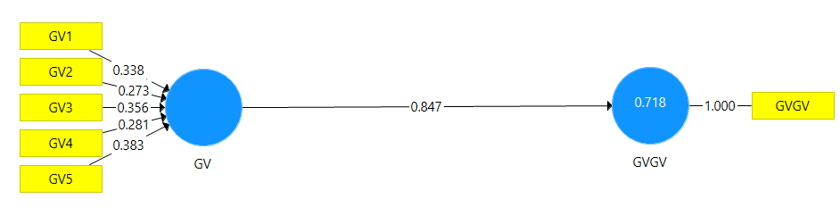
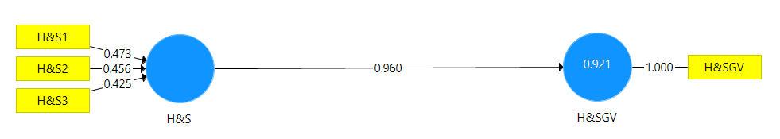
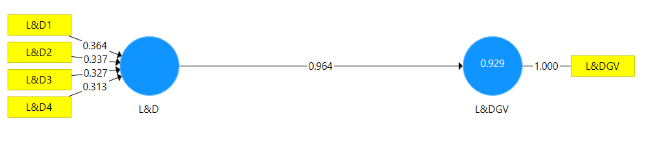
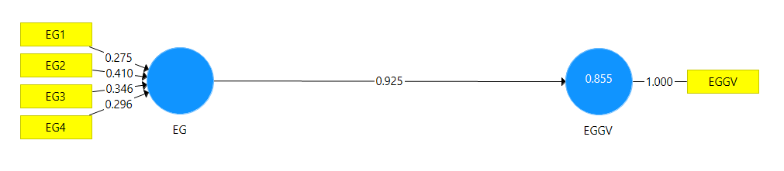
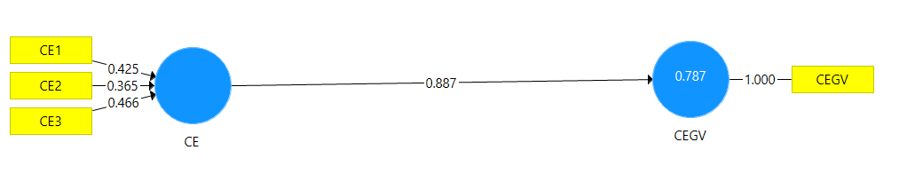
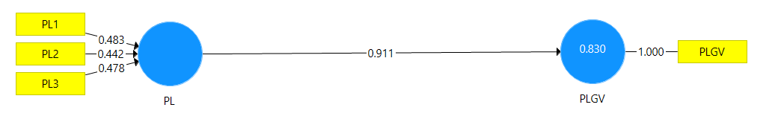
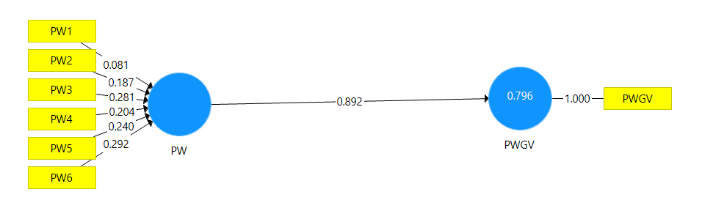
Figure 8: Nomological Validity of First-Order Constructs

3.2.3. Second-Order Measurement Model Validation
In a similar vein, we substantiated the second-order measurement model through three methodological processes: discriminant validity, convergent validity, and significance level. Initially, discriminant validity was assessed. Given that all VIF values ranged from 1.293 to 3.88, which is significantly below the conservative threshold of 5 (Hair et al., 2014), the issue of multicollinearity doesn’t present a concern for the indicators of this formative construct (Figure 9).
Subsequently, we proceeded to evaluate the outer weights & their associated significance. The significance of the outer weights was determined through bootstrapping with a sample size of 5,000 (Hair et al., 2017). Comparative examination between them is made easier by the standardization of the outer weight values. The results of the study (Table 5; Figure 10) showed that the t-statistics, p-values, outer weights, and outer loadings (threshold limit 0.5) for each indicator were more than the threshold limit and significant at p 0.001 & 0.05 (Hair et al., 2013). The alignment of significant p-values and positive outer weights in both Python and SmartPLS underscores the reliability and robustness of each construct’s contribution, enhancing the validity and trustworthiness of the formative construct (Figure 11).
Third, to investigate the interrelationships among the constructs, the notion of nomological validity was utilized (Hair at al., 2010). We have chosen to use a single reflective indicator in conjunction with a reflective measure construct as the outcome variable, out of the many alternatives available for the scaling methodology (Diamantopoulos et al., 2008). To address the issues of under-identification and to support validation efforts, a particular reflecting indicator of ES (ESGV – I have a satisfying life as an employee) has been used as a worldwide measure. The ES correlation coefficient was found to be 0.867, exceeding the suggested cutoff of 0.70 and was statistically significant at the 0.01 level (Figure 12).
Table 5: Discriminant Validity and Significance Level of Second-Order Constructs
Second-Order Constructs | Outer Weight | Outer Loading | T Statistics (|O/STDEV|) | P Values | VIF
HR -> ES | 0.102 | 0.632 | 3.616 | 0 | 1.705
H&S -> ES | 0.196 | 0.527 | 7.82 | 0 | 1.412
GV -> ES | 0.196 | 0.55 | 8.231 | 0 | 1.373
CE -> ES | 0.175 | 0.501 | 7.574 | 0 | 1.293
PL -> ES | 0.066 | 0.782 | 1.965 | 0.049 | 3.88
PW -> ES | 0.328 | 0.913 | 9.44 | 0 | 3.346
EG -> ES | 0.243 | 0.719 | 7.891 | 0 | 2.527
L&D -> ES | 0.166 | 0.663 | 5.594 | 0 | 2.165

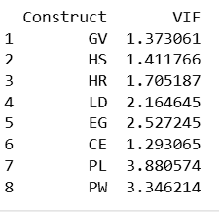
Figure 9: VIF of Second-Order Constructs by Python

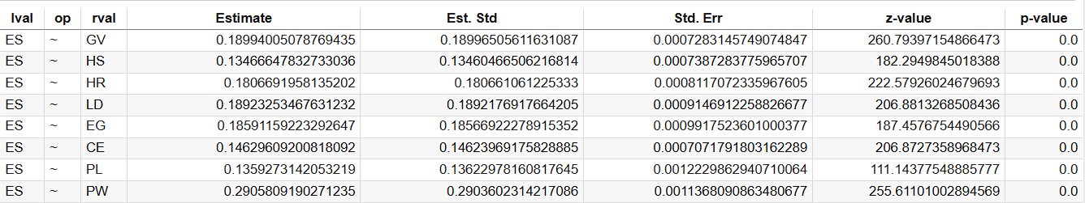
Figure 10: Outer Weight & P-value of Second First-Order Constructs by Python

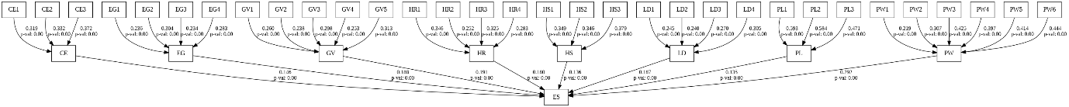
Figure 11: Outer Weight & P-value by Python

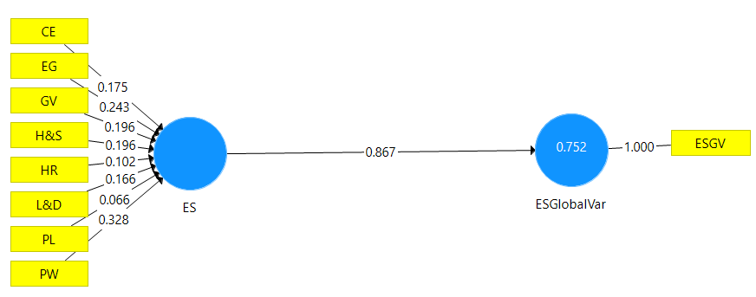
Figure 12: Nomological Validity of Second-Order Construct

4. Discussion & Implications
Aimed at bridging the existing gap in ES research, the primary objective of this research was to explore ES practices within manufacturing organizations in India. The outcomes of this investigation shed light on numerous critical discussions. The manufacturing sector serves as the cornerstone of the Indian economy, contributing 17% to the nation's GDP & employing 27.3 million individuals (Ministry of Labour & Employment Labour Bureau, 2021). Recently, the sector has experienced a significant imbalance due to various factors; include increased mortality rates, labor law violations, poor working conditions, and mental health issues. A significant percentage of the workforce, 59%, reports dissatisfaction, prompting stakeholders to demand improvements (HRKatha, 2022). India is categorized within a Low Labor Rights index, reflecting inadequate labor regulations prevalent in the nation (Gallup, 2024). Furthermore, the entry of millennials and Generation Z has transformed workplace attitudes and expectations (The Economics Times, 2022). Unlike baby boomers, younger generations seek fulfilment and purpose in their careers rather than mere job security. They value organizations that focus on their professional growth and expect managers to adopt coaching roles. Employees desire ongoing dialogue about their performance rather than being assessed solely through annual reviews. Millennials have actively challenged traditional workplace structures, urging companies to rethink their environments. Hence, organizational leaders are adapting human capital strategies to meet the needs of these generations & aim to reform workplace practices. However, HR departments face challenges in engaging younger employees & making workplace happy effectively. As, it is essential to differentiate between employee engagement and mere happiness, as traditional metrics often conflate the two. True engagement reflects employees' psychological investment in their work. They exhibit a comprehensive awareness of their duties, possess essential resources, and receive direction from a supportive manager and cooperative team. They recognize the importance of their roles. They are sufficiently prepared for employment. Consequently, we have developed the ES scale to enhance workplace satisfaction. This framework draws upon the Buddhist middle path philosophy, advocating for a balanced interdependent existence (Ura, 2012). However, it rejects the pursuit of economic profit as the sole aim. It embodies the principle of ‘Development with Values.’ This framework is characterized as: Holistic: Recognizing individuals' diverse spiritual, material, physical, and social needs; Balanced: Emphasizing harmonious progression towards happiness; Collective: Acknowledging happiness as a shared experience; Sustainable: Aiming for well-being for current and future employees; Equitable: Pursuing just and equitable well-being distribution (Ura, 2012). This concept encapsulates a vision of development that prioritizes holistic happiness as the ultimate value.
The outcomes of this investigation elucidate several significant discussions and implications, which will be elaborated upon in the subsequent section.
4.1. Theory building in ES
We applied three criteria to assess limited literature on holistic Employee Sustainability (ES), focusing on its definitions, dimensions, and global reporting frameworks. Our analysis reveals that ES definitions must explicitly include internal social practices and employee-centric sustainability aspects to reflect true organizational intentions. A complete understanding of ES requires integrating all five sustainability dimensions—CSR, green HRM, supply chain sustainability, economic sustainability, and sustainable HRM. We adopt a consumer-oriented perspective, emphasizing the need to align ES with global ESG frameworks and happiness indices (e.g., GRI, World Happiness Report, GNH). Without these, ES remains conceptually incomplete.
4.2. Conceptualization of ES
This study developed and validated an Employee Sustainability (ES) scale tailored to the Indian manufacturing sector, addressing the region’s unique socio-cultural context. Existing ES scales, designed for developed nations, lack generalizability to India. ES is conceptualized as a second-order formative construct comprising eight first-order dimensions: egalitarianism, health and safety, human rights, learning and development, cultural enrichment, governance, philanthropy, and psychological well-being. Quantitative results confirm the model's validity (R² > 78%), with psychological well-being emerging as the most critical dimension. Guided by the PERMA model, organizations are encouraged to support mental wellness through initiatives like meditation and counseling. Overall, these dimensions are essential for a comprehensive understanding of ES.
4.3 Managerial Implications
When entering diverse cultural markets, manufacturing firms must prioritize cultural congruence to align their offerings with employee needs (Huang & Rundle-Thiele, 2014). This article provides significant insights for social sustainability (SS) and HR professionals in Indian manufacturing, particularly in relation to employee well-being. The research confirms that employee sustainability (ES) comprises eight factors, with psychological well-being being the most critical for employee happiness. As Nadeem (2015) states, a company's reputation and worker happiness are interlinked. A healthy work-life balance fosters emotional and physical well-being, reducing stress and enhancing productivity (Ura, K., 2012).
Psychological well-being is key to leveraging resources and creating synergies in organizations. Manufacturing firms should develop support systems to fulfill their responsibilities toward employees, which will improve their brand image and foster a holistic view of the supply chain experience. Understanding ES dynamics is essential for integrating personnel, policies, and procedures that promote employee well-being cost-effectively. Prioritizing both financial and social dimensions of organizational effectiveness is crucial, as a satisfied employee leads to a satisfied consumer (Mark, 2013).
The employee-as-consumer concept is emerging, and organizations must adeptly navigate this shift. Creating a supportive environment is vital for enhancing SS and attracting long-term consumers. Interpersonal relationships also play a crucial role, with positive word-of-mouth influencing job selection decisions. Firms can enhance relationships with employees, suppliers, and consumers using relationship marketing. To ensure cultural alignment and improve employee perceptions of ES practices, organizations should invest in regular training, employee surveys, and annual reports, as suggested by Kim et al. (2017) and Youn et al. (2018). Additionally, managers must adapt to local cultural contexts to align ES practices with employee expectations (Raub, 2008).

5. Limitations & Future Research Directions
Initially, the organizations included in the sample are predominantly situated in the eastern regions of India. Consequently, the findings may not accurately depict employees’ perceptions of ES in other geographical areas of India. This underscores the necessity for validation regarding the extent to which these findings can be generalized to other regions in India theoretically, facilitating a deeper understanding of manufacturing organizations functioning within India in practice. Secondly, our study was confined to the examination of employee happiness as the principal outcome variable. Future empirical investigations may incorporate additional key variables—such as job crafting, job embeddedness, or turnover intention—to gain deeper insights into the impact of ES on work performance..

Statements and Declarations: Authors have nothing to declare and has no competing interests & funding.

References
Armstrong, J.B. & T.S. Overton. (1977), “Estimating Non response Bias in Mail Surveys,” Journal of Marketing Research, 14 (August), 396–402.
Aust, I., Matthews, B., & Muller-Camen, M. (2020). Common good HRM: a paradigm shift in sustainable HRM?. Human Resource Management Review, 30(3), 100705.
Beer, M., Boselie, P., & Brewster, C. (2015). Back to the future: Implications for the field of HRM of the multi-stakeholder perspective proposed 30 years ago. Human Resource Management, 54(3), 427–438.
Beer, M., Spector, R., Lawrence, P., Quinn Mills, D., & Walton, R. (1984). Human Resource Management: A General Managers Perspective, Glencoe III: Free Press.
Blalock, H.M. (1982). Conceptualization and measurement in the social sciences. Beverly Hills: Sage Publications.
Blowfield, M., & Frynas, J.G. (2010). Setting new agendas: critical perspectives on corporate social responsibility in the developing world. Int.Aff.81(3),499–513.
Bollen, K., & Lennox, R. (1991). Conventional wisdom on measurement: A structural equation perspective. Psychological Bulletin, 110(2),305–314.
Bollen, K.A., & Bauldry,.(2011). Three cs in measurement models: Causal indicators, composite indicators, and covariates (english). Psychological Methods,16(3),265–284.
Boudreau, M.-C., Gefen, D., & Straub, D. W. (2001). “Validation in Information Systems Research: A State-of-the-Art Assessment,” MIS Quarterly (25:1), pp. 1-26.
Branco, M., & Rodrigues, L. (2006), ‘Corporate Social Responsibility and Resource-Based Perspectives,’ Journal of Business Ethics, 69, 2, 111–132.
Braun V., & Clarke V. (2006). Using thematic analysis in psychology. Qualitative Research in Psychology, 3(2), 77–101. https://doi.org/10.1191/1478088706qp063oa
Brundtland, G. (ed.) (1987). Report of the World Commission on Environment and Development: Our Common Future, Oxford: Oxford University Press.
Carroll, A. B. (1999). Corporate social responsibility evolution of a definitional construct. Bus. Soc. 38(3),268–295.
Deloitte's Mental Health Survey. (2022). Mental health and well-being in the workplace. https://www2.deloitte.com/content/dam/Deloitte/global/Documents/Life-Sciences-Health-Care/gx-mental-health-2022-report-noexp.pdf
Diamantopoulos, A. (2013). Mimic models and formative measurement: Some thoughts on Lee, Cadogan & Chamberlain. AMS Review, 3(1), 30–37.
Diamantopoulos, A., & Winklhofer, H.M. (2001). Index construction with formative indicators: An alternative to scale development. Journal of Marketing Research, 38(2), 269–277.
Diamantopoulos, A., Riefler, P., & Roth, K.P. (2008). Advancing formative measurement models. Journal of Business Research, 61(12), 1203–1218.
Duarte, P. and Amaro, S. (2018). “Methods for modelling reflective-formative second order constructs in PLS: an application to online travel shopping”, Journal of Hospitality and Tourism Technology, Vol. 9 No. 3, pp. 295-313.
Ehnert, I. (2011). ‘Sustainability and Human Resource Management,’ in The Future of Employment Relations, eds. A. Wilkinson and K. Townsend, Hampshire: Palgrave Macmillan, pp. 215–237.
Ehnert, I., Parsa, S., Roper, I., Wagner, M., & Muller-Camen, M. (2016). Reporting on sustainability and HRM: A comparative study of sustainability reporting practices by the world's largest companies. Int. J. Hum. Resour. Manag. 27(1), 88-108, http://dx.doi.org/10.1080/09585192.2015.1024157.
Eizenberg, E., & Jabareen, Y. (2017). Social sustainability: A new conceptual framework. Sustainability, 9(1), 68.
European Commission (2001). Green Paper: Promoting a European Framework for Corporate Social Responsibility. Commission of the European Communities, Brussels, Belgium.
Fatma, M., Rahman, Z., & Khan, I. (2016). Measuring consumer perception of CSR in tourism industry: scaledevelopmentandvalidation.J.Hosp.Tour.Manag.27,39–48.
Florman, M., Klinger-Vidra, R., & Facada, M.J. (2016). A Critical Evaluation of Social Impact Assessment Methodologies and a Call to Measure Economic and Social Impact Holistically
Follett, M. P. (1926). The giving of orders. In J. M. Shafritz & J. S. Ott (Eds.), Classics of Organization Theory (7th ed., pp. 156–162). Wadsworth.
Friedman, M. (1970). The social responsibility of business is to increase profits. The New York Times Magazine, (September 13), 32–33.
Gallup. (2022). State of the Global Workplace 2022 Report. https://www.gallup.com/workplace/349484/state-of-the-global-workplace.aspx (accessed 2022)
Gallup. (2023). State of the Global Workplace 2023 Report. https://www.gallup.com/workplace/349484/state-of-the-global-workplace.aspx (accessed 2023)
Gallup. (2024). State of the Global Workplace 2024 Report. https://www.gallup.com/workplace/349484/state-of-the-global-workplace.aspx (accessed 2024)
Gimenez, C., & Tachizawa, E.M. (2012). Extending sustainability to suppliers: a systematic literature review. Supply Chain Manag. Int. J. 17 (5), 531–543.
Good, P. (2006), Resampling Methods: A Practical Guide to Data Analysis, Springer Science & Business Media, Birkhũser, Boston, MA.
Grace, D., Ross, M. & King, C. (2020). “Brand fidelity: scale development and validation”, Journal of Retailing and Consumer Services, Vol. 52, p. 101908.
GRI. (2015). Global Reporting Initiative (GRI) index 2015. Retrieved frm https://documents1.worldbank.org/curated/en/523821467987823156/pdf/100004-WP-PUBLIC-Box393216B-World-Bank-GRI-Index-2015.pdf.
Guest, D. E. (1987). Human resource management and industrial relations. Journal of Management Studies, 24(5), 503–521.
Hair, J.F. Jr, Black, W.C., Babin, B.J. & Anderson, R.E. (2010). Multivariate Data Analysis: A Global Perspective, 7th ed., Pearson Education, Upper Saddle River, NJ.
Hair, J.F., Hult, G.T.M., Ringle, C., & Sarstedt, M. (2013). A Primer on Partial Least Squares Structural Equation Modelling (PLS-SEM). Sage Publications, London.
Hair, J. F., Jr., Matthews, L. M., Matthews, R. L., & Sarstedt, M. (2017). PLS SEM or CB-SEM: Updated guidelines on which method to use. International Journal of Multivariate Data Analysis, 1(2), 107–123.
Hair, J. F., Jr., Sarstedt, M., Hopkins, L., & Kuppelwieser, V. G. (2014). Partial least squares structural equation modeling (PLS- SEM): An emerging tool in business research. European Business Review, 26(2), 106–121.
Hair, J. F., Hult, G. T. M., Ringle, C. M., & Sarstedt, M. (2022). A primer on partial least squares structural equation modeling (PLS-SEM) (3 ed.). Thousand Oaks, CA: Sage.
Hair, J. F., Risher, J. J., Sarstedt, M., & Ringle, C. M. (2019). When to use and how to report the results of PLS-SEM. European Business Review, 31(1), 2–24.
Hall, J., Matos, S., & Silvestre, B. (2012). Understanding why firms should invest in sustainable supply chains: a complexity approach. Int. J. Prod. Res. 50 (5), 1332–1348.
Helliwell, J. F., Layard, R., Sachs, J. D., De Neve, J.-E., Aknin, L. B., & Wang, S. (Eds.). (2024). World happiness report 2024. University of Oxford: Wellbeing Research Centre. https://happiness-report.s3.amazonaws.com/2024/WHR+24.pdf
HRKatha. (2022). 59% Indian employees may have mental health issues, 55% are emotionally burnt out. Retrieved from https://www.hrkatha.com/research/59-indian-employees-may-have-mental-health-issues-55-are-emotionally-burnt-out/
Human Development Report, United Nations Development Programme. (2024). Human Development Report. Retrieved from https://www.undp.org/india/publications/human-development-report-2023-24-0
Hutchins, M.J., & Sutherland, J.W. (2008). An exploration of measures of social sustainability and their application to supply chain decisions. J. Clean. Prod. 16 (15), 1688–1698.
International Labour Organization. (2024). India Employment Report 2024. Retrieved from https://www.ilo.org/sites/default/files/2024-08/India%20Employment%20-%20web_8%20April.pdf
Jarvis, C. B., Mackenzie, S. B., & Podsakoff, P.M. (2003). A critical review of construct indicators and measurement model misspecification in marketing and consumer research. Journal of Consumer Research, 30(2), 199–218.
Jöreskog, K. G. (1969). A general approach to confirmatory maximum likelihood factor analysis. Psychometrika, 34(2), 183–202.
Kotler, P. (1986). Principles of marketing. Prentice-Hall.
Kramar, R. (2012). ‘Human Resources: An Integral Part of Sustainability,’ in Current Research in Sustainability, ed. G. Jones, Melbourne: Tilde University Press, pp. 153–178.
Law, K. S., Chi-Sum, W., & Mobley, W.M. (1998). Toward a taxonomy of multidimensional constructs. Academy of Management Review, 23(4), 741–755.
Lee, N., & Cadogan,J. W. (2013). Problems with formative and higher-order reflective variables. Journal of Business Research, 66(2), 242–247.
Mackenzie, S. B., Podsakoff, P.M., & Jarvis, C. B. (2005). The problem of measurement model misspecification in behavioral and organizational research and some recommended solutions. Journal of Applied Psychology, 90(4), 710–730.
Mani, V., Agarwal, R., Gunasekaran, A., Papadopoulos, D., Dubey, R., & Childe, S. J. (2016a). Social sustainability in the supply chain: Construct development and measurement validation. Ecological Indicators, 71, 270–279.
Mani, V., Gunasekaran, A., Papadopoulos, T., Dubey, R., & Benjamin, H. (2016b). Supply chain social sustainability for developing nations: evidence from India. Resour. Conserv. Recycl. 111, 42–52.
Mani, V., Gunasekaran, A., & Delgado, C. (2018). Enhancing supply chain performance through supplier social sustainability: An emerging economy perspective. International Journal of Production Economics, 195, 259-272.
Meade, A. W., & Craig, S. B. (2012). Identifying careless responses in survey data. Psychological Methods, 17(3), 437–455. https://doi.org/10.1037/a0028085
Mick, D. G. (2006). Meaning and mattering through transformative consumer research. Advances in Consumer Research, 33, 1–4.
Ministry of Labour & Employment Labour Bureau. (2021). Annual Report 21-22. Retrieved from. https://labour.gov.in/sites/default/files/annual_report-21-22.pdf.
Mint. (2022). Over 86% of employees in India may resign in next 6 months: Report. Retrieved from https://www.livemint.com/news/over-86-of-employees-in-india-may-resign-in-next-6-months-report-11654686876443.html
Montalbán-Domingo, L., Garcia-Segura, T., Sanz, M. A., & Pellicer, E. (2018). Social sustainability criteria in public-work procurement: An international perspective. Journal of cleaner production, 198, 1355-1371.
Nadeem, M. (2015). Employee's (Happy) Branding Corporate's' Social'Reputation: Can You Put a Price on That?. International Journal of Marketing Studies, 7(6).
Ng, I. C. L., & Forbes, J. (2009). Education as service: The understanding of university experience through the service logic. Journal of Marketing for Higher Education, 19(1), 38– 64. https://doi. org/10.1080/08841240902904703
O’Connor, C., & Joffe, H. (2020). Intercoder reliability in qualitative research: debates and practical guidelines. International journal of qualitative methods, 19, 1609406919899220.
Oswald, A.J., Proto, E., & Sgroi, D. (2015). Happiness and Productivity. Journal of Labor Economics, 33(4), 789-822. Retrieved from http://wrap.warwick.ac.uk/63228/7/WRAP_Oswald_681096. pdf
Peter, J. P. (1981). Construct validity: A review of basic issues and marketing practices. Journal of Marketing Research (JMR), 18(2), 133–145
Petter, S., Straub, D., & Rai, A. (2007). Specifying formative constructs in information systems research. MIS Quarterly, 31(4), 623–656.
Podsakoff, P.M., Mackenzie, S. B., Jeong-Yeon, L., & Podsakoff, N.P. (2003). Common method biases in behavioral research: A critical review of the literature and recommended remedies. Journal of Applied Psychology, 88(5), 879.
Rigdon, E. E., Sarstedt, M., & Ringle, C. M. (2017). On comparing results from CB-SEM and PLS-SEM: Five perspectives and five recommendations. Marketing: ZFP–Journal of Research and Management, 39(3), 4–16.
Sarstedt, M., Ringle, C. M., & Hair, J. F. (2017). Partial least squares structural equation modelling. Handbook of Market Research, 26(1), 1–40.
Statista Market Insights. (2023). Number of people employed across the manufacturing sector in India from financial year 2020 to financial year 2023. Retrieved from https://www.statista.com/statistics/1284237/india-manufacturing-sector-employment/
The Economics Times. (2022). Gen Z work-life expectations reshaping HR job profile. https://economictimes.indiatimes.com/jobs/hr-policies-trends/gen-z-work-life-expectations-reshaping-hr-job-profile/articleshow/115742985.cms?from=mdr
Thom, N., & Zaugg, R. J. (2004). Nachhaltiges und innovatives Personal management: Spitzengruppenbefragung in europäischen Unternehmungen und Institutionen, in: Schwarz, E. J., Nachhaltiges Innovationsmanagement. Gabler Verlag, p. 215-245.
Travia, R. M., Larcus, J. G., Andes, S., & Gomes, P. G. (2020). Framing well- being in a college campus setting. Journal of American College Health, 1– 15. https://doi.org/10.1080/07448 481.2020.1763369
United Nations Public Administration Network [UNPAN]. (2006). A Comprehensive Guide for Social Impact Assessment. UNPAN. Retrieved from http://unpan1.un.org/intradoc/groups/public/documents/cgg/u npan026197.pdf
Ura, Karma. (2009). A Proposal for GNH Value Education. Thimphu, Bhutan.
Ura, K. (2012). Gross National Happiness and Buddhism. Retrieved from http://www.kosei shuppan.co.jp/english/text/mag/2007/07_101112_10.html
Wilcox, J. B., Howell, R. D., & Breivik, E. (2008). Questions about formative measurement. Journal of Business Research, 61(12), 1219–1228.
Wilkinson, A., Hill, M., & Gollan, P. (2001). Int. J. Oper. Prod. Manag. 21(12), 1492-1502, http://dx.doi.org/10.1108/01443570110410865.
Wood, D.J. (1991). Corporate social performance revisited. Acad. Manag. Rev. 16 (4), 691–718.

